**CHAPTER – 1**

**INTRODUCTION TO PROJECT**

**1.1 ABOUT PROJECT:**

The "College Website" has been developed to override the problems prevailing in the practicing manual system. This software is supported to eliminate and in some cases reduce the hardships faced by this existing system. Moreover this system is designed for the particular need of the company to carry out operations in a smooth and effective manner.

The application is reduced as much as possible to avoid errors while entering the data. It also provides error message while entering invalid data. No formal knowledge is needed for the user to use this system. Thus by this all it proves it is user-friendly. College Website, as described above, can lead to error free, secure, reliable and fast management system. It can assist the user to concentrate on their other activities rather to concentrate on the record keeping. Thus it will help organization in better utilization of resources.

Every organization, whether big or small, has challenges to overcome and managing the information of Student, College, Course, Faculty, Fees. Every College Website has different College needs, therefore we design Managerial requirements.

**1.2 MOTIVATION:**

The purpose of College Website is to automate the existing manual system by the help of computerized equipment’s and full-fledged computer software, fulfilling their requirements, so that their valuable data/information can be stored for a longer period with easy accessing and manipulation of the same. The required software and hardware are easily available and easy to work with.

College Website, as described above, can lead to error free, secure, reliable and fast management system. It can assist the user to concentrate on their other activities rather to concentrate on the record keeping. Thus it will help organization in better utilization of resources. The organization can maintain computerized records without redundant entries. That means that one need not be distracted by information that is not relevant, while being able to reach the information.

The aim is to automate its existing manual system by the help of computerized equipment’s and full-fledged computer software, fulfilling their requirements, so that their valuable data/information can be stored for a longer period with easy accessing and manipulation of the same. Basically the project describes how to manage for good performance and better services for the clients.

**1.3 PROBLEM DEFINITION:**

The old manual system was suffering from a series of drawbacks. Since whole of the system was to be maintained with hands the process of keeping, maintaining and retrieving the information was very tedious and lengthy. The records were never used to be in a systematic order. There used to be lots of difficulties in associating any particular transaction with a particular context. If any information was to be found it was required to go through the different registers, documents there would never exist anything like report generation. There would always be unnecessary consumption of time while entering records and retrieving records. One more problem was that it was very difficult to find errors while entering the records. Once the records were entered it was very difficult to update these records.

The reason behind it is that there is lot of information to be maintained and have to be kept in mind while running the business .For this reason we have provided features Present system is partially automated (computerized), actually existing system is quite laborious as one has to enter same information at three different places.

**1.4 HISTORY:**

The project college website has been developed by taking references from various other websites that were already available on the internet. These sites were from various institutional organizations, shopping sites, business sites etc.

The project has been made and compared to those references and was possible that we could make our project upto the best of what we are seeking an example from.

**1.5 FEASIBILITY STUDY:**

After doing the project College Website, study and analyzing all the existing or required functionalities of the system, the next task is to do the feasibility study for the project. All projects are feasible - given unlimited resources and infinite time.

Feasibility study includes consideration of all the possible ways to provide a solution to the given problem. The proposed solution should satisfy all the user requirements and should be flexible enough so that future changes can be easily done based on the future upcoming requirements.

**A. Economic Feasibility**

This is a very important aspect to be considered while developing a project. We decided the technology based on minimum possible cost factor.

* All hardware and software cost has to be borne by the organization.
* Overall we have estimated that the benefits the organization is going to receive from the proposed system will surely overcome the initial costs and the later on running cost for system.

**B. Technical Feasibility**

This included the study of function, performance and constraints that may affect the ability to achieve an acceptable system. For this feasibility study, we studied complete functionality to be provided in the system, as described in the System Requirement Specification (SRS), and checked if everything was possible using different type of frontend and backend platform.

**C. Operational Feasibility**

It is very user friendly and all inputs to be taken all self-explanatory even to a layman. Besides, a proper training has been conducted to let know the essence of the system to the users so that they feel comfortable with new system. As far our study is concerned the clients are comfortable and happy as the system has cut down their loads and doing.

**CHAPTER - 2**

**PROJECT REQUIREMENTS ANALYSIS AND SPECIFICATIONS**

**2.1 INTRODUCTION:**

The "College Website" has been developed to override the problems prevailing in the old website this website is supported to eliminate and in some cases reduce the hardships faced by this existing website. Moreover this website is designed for the particular need to carry out operations in a smooth and effective manner.

The application is reduced as much as possible to avoid errors while entering the data. It also provides error message while entering invalid data. No formal knowledge is needed for the user to use this system. Thus by this all it proves it is user-friendly. College Website, as described above, can lead to error free, secure, reliable and fast services. It can assist the user to concentrate on their other activities rather to concentrate on its lacking functions. Every organization, whether big or small, has challenges to overcome and managing the information of Student, College, Course, Faculty, Fees. Every College Website has different College needs, therefore we designed it with some new features.

**OBJECTIVES OF PROJECT**

* The main objective of the Project on College Website is to manage the details of College, Student, Employee, Course, Fees.
* It manages all the information about College, Faculty, Fees, college. The project is totally built at administrative end and thus only the administrator is guaranteed the access.
* The purpose of the project is to build an application program to reduce the manual work for managing the College, Student, Faculty, employee .
* It tracks all the details about the Employee, Course, Fees, Activities performed, results of the students and many more.

**2.2 FUNDAMENTTAL REQUIREMENTS:**

**2.2.1 Software Requirement:**



When creating websites for school projects or university courses, the WordPress.com website builder is the ideal tool. First and foremost, it’s both free and intuitive to use. No matter our level of experience, it could launch our new site within 24 hours

So, whether we’re making a photography portfolio or a blog where we can post assignments, here are a few reasons to do it with WordPress.com.

**1.** **Free to use**

Every WordPress.com website is free for up to 3 GB of storage space.

**2. No site maintenance required**

With a WordPress.com site, we don’t have to perform any of the ongoing updates ourself. All backups, optimization, and maintenance are automatically included with our free website.

**3. A wide selection of templates**

So, whether we’re making a photography portfolio or a blog where we can post assignments, here are a few reasons to do it with WordPress.com.

The versatility of available WordPress.com templates makes all kinds of websites possible. Select the layout that we find most suitable, and we’re set.

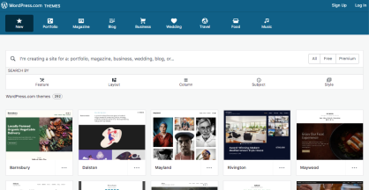

**4. Visual editing**

We don’t need to know how to code to create content on our WordPress.com site. The visual editor makes posting simple and intuitive.

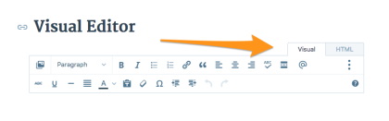

**5. Pages for static content**

If we are posting content on our website that will not change, use the Pages tool. Whether it’s an about page or a class assignment list, this is the perfect place for static content.

**6. Posts for sharing fresh information**

Posts, on the other hand, are ideal for featuring new content as it’s created. We can use posts to share book reviews, class assignments, photos, video, slides, and more.

It’s also possible for classmates, collaborators, or teachers to subscribe and get notifications whenever new posts are published.

**7. Comments**

For sites where we want to facilitate discussion, we can allow comments. The commenting function is enabled by default, but we’re able to turn it off, if we so choose. Go to My Site(s) → Manage → Settings. Click on the Discussion tab. Under “Default Article Settings,” toggle on/off the option to “Allow people to post comments on new articles.”

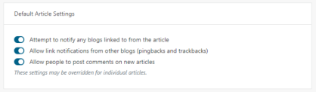

**2.3 SOFTWARE SPECIFICATIONS:**

**WORD PRESS:**

When creating websites for school projects or university courses, the WordPress.com website builder is the ideal tool. First and foremost, it’s both free and intuitive to use. No matter our level of experience, it could launch our new site within 24 hours

So, whether we’re making a photography portfolio or a blog where we can post assignments, here are a few reasons to do it with WordPress.com

**The following are the working tools and areas that were used in word press to make the website:**

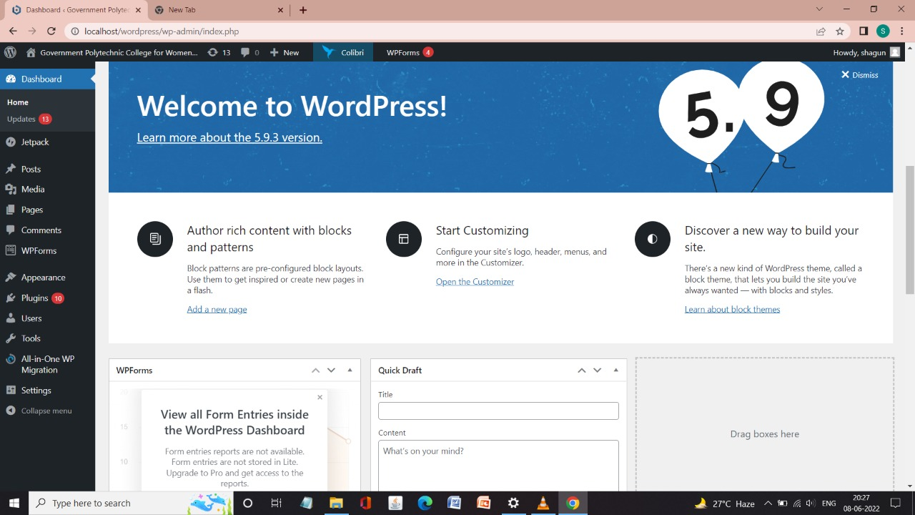**1. Dashboard: The front page of wordpress contains all the tools to operate:**

**Fig2.3.1**

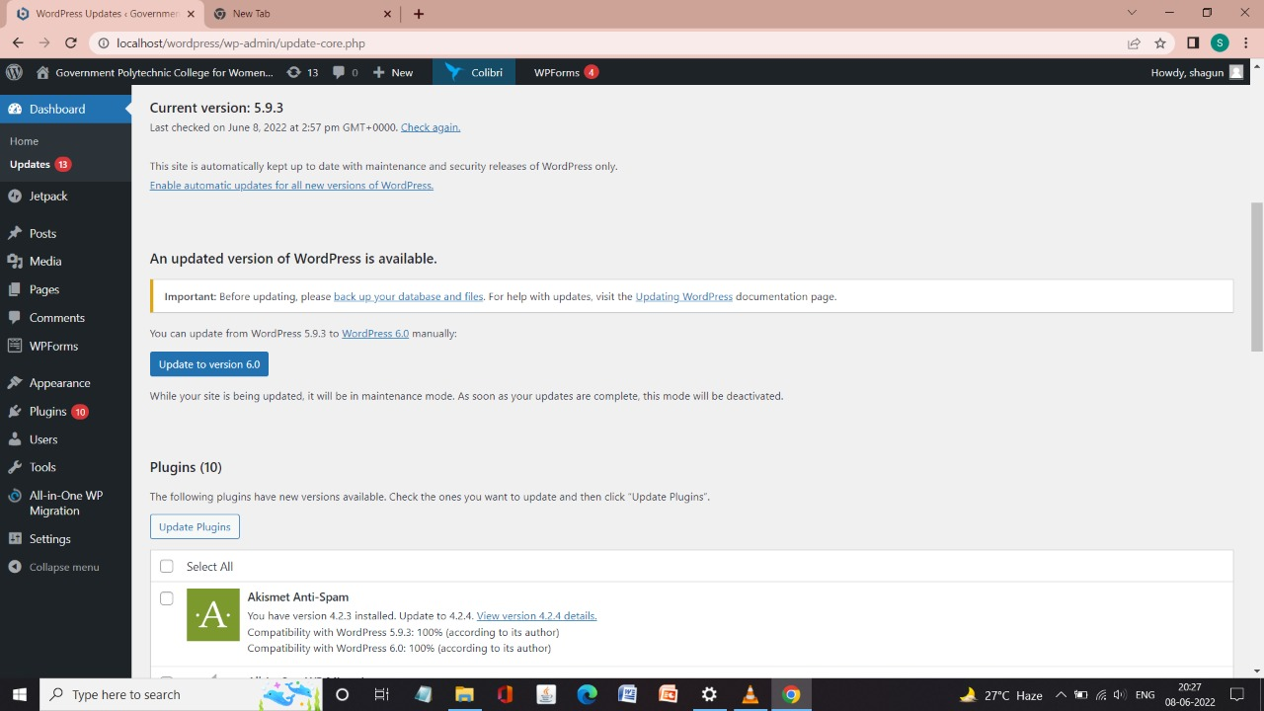**2. This is where we update new versions of word press:**

**Fig2.3.2**

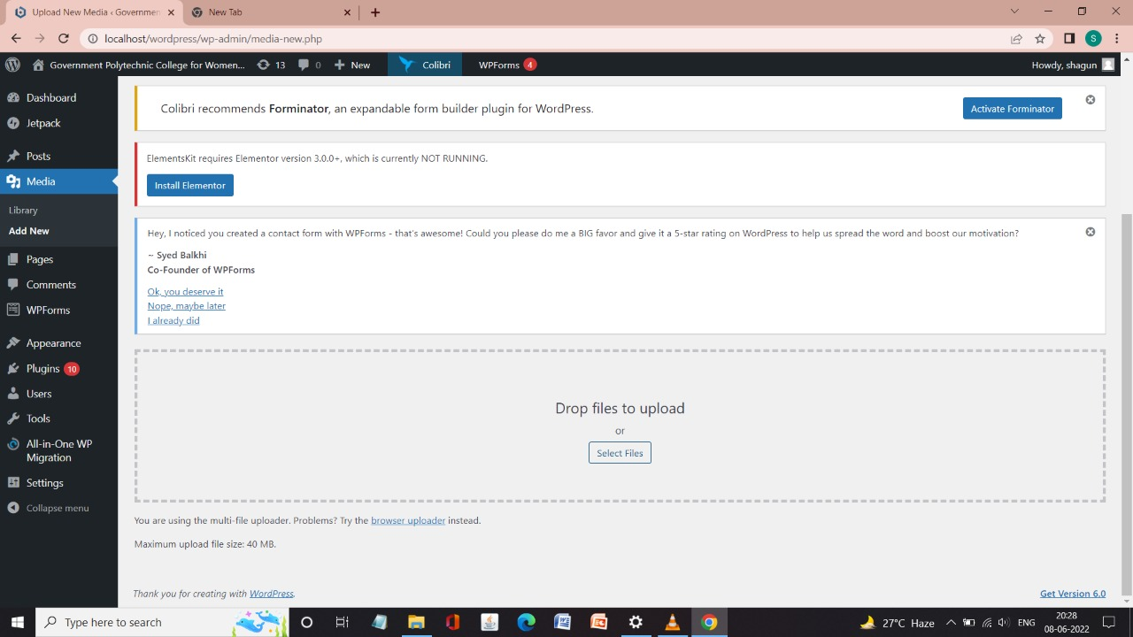**3. Media: It’s where we add or upload our photos to the website:**

**Fig.2.3.3**

**4. Here all the pages of website are contained:**

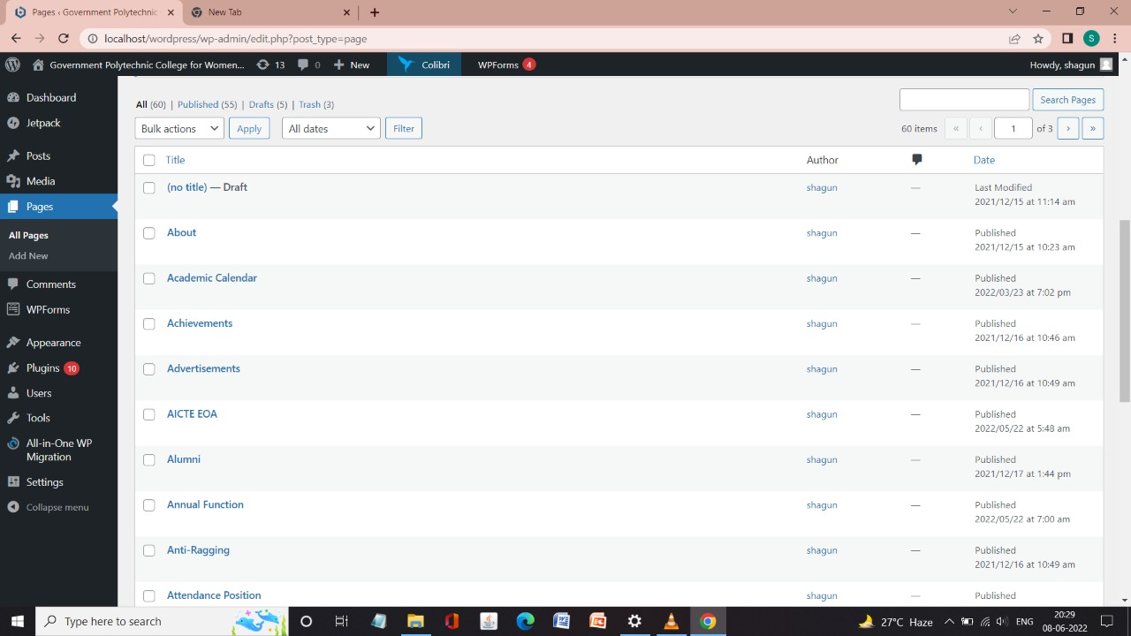

**Fig.2.3.4**

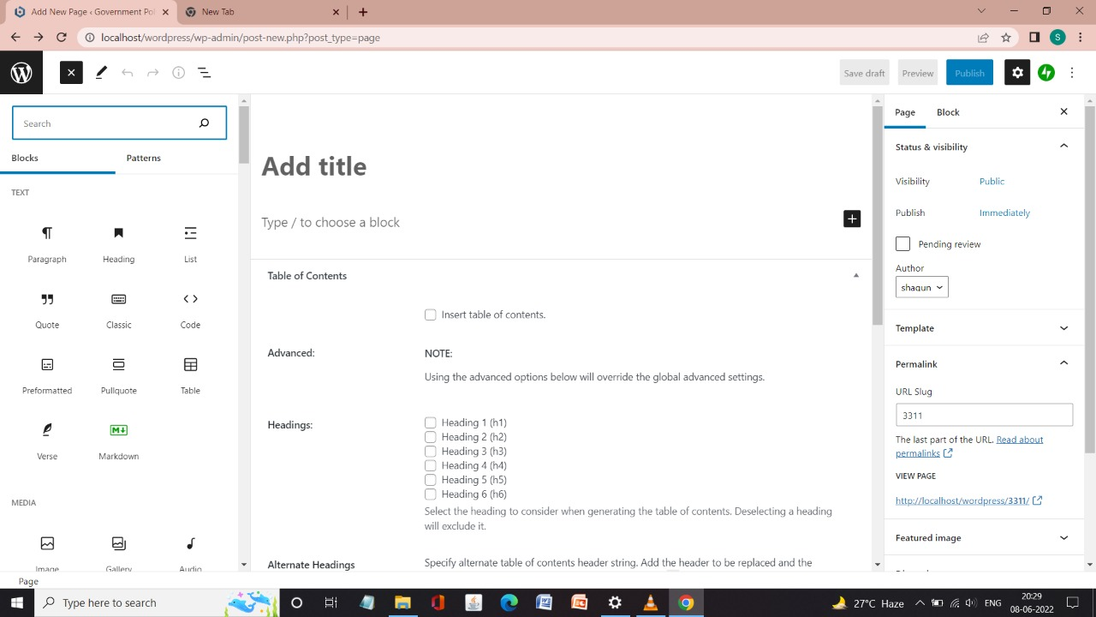**5. Here we are adding are pages to the website:**

**Fig.2.3.5**

**6. Themes: Here all the themes are located to customize are website:**

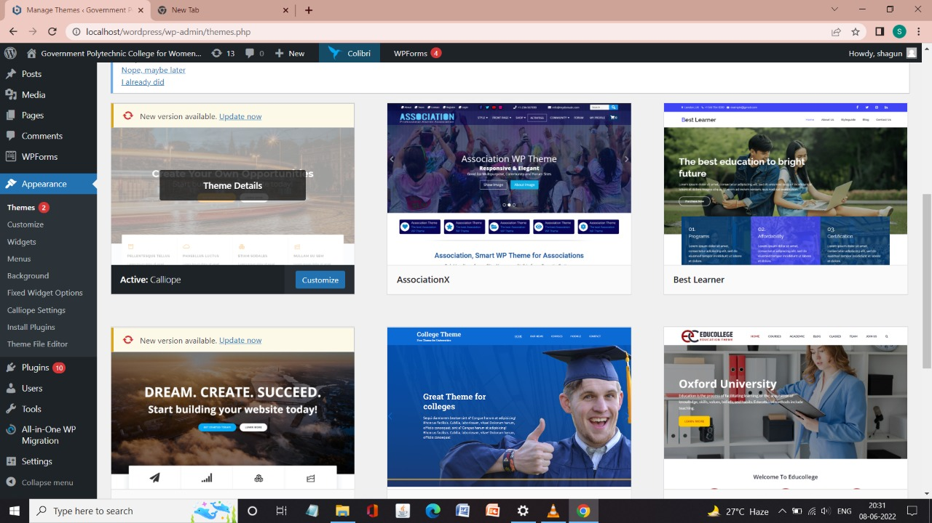

**Fig.2.3.6**

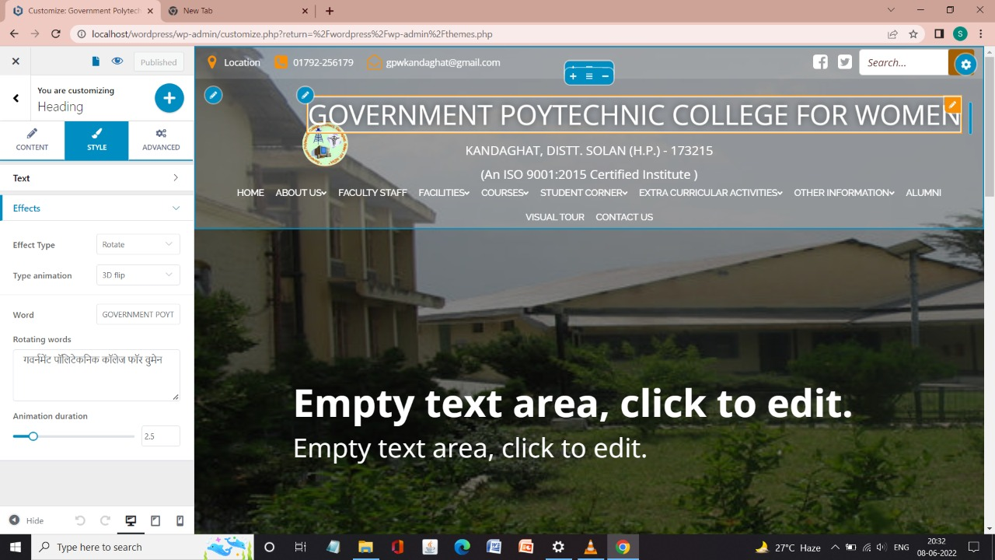**7. This how we edit our page in word press:**

**Fig2.3.7a**

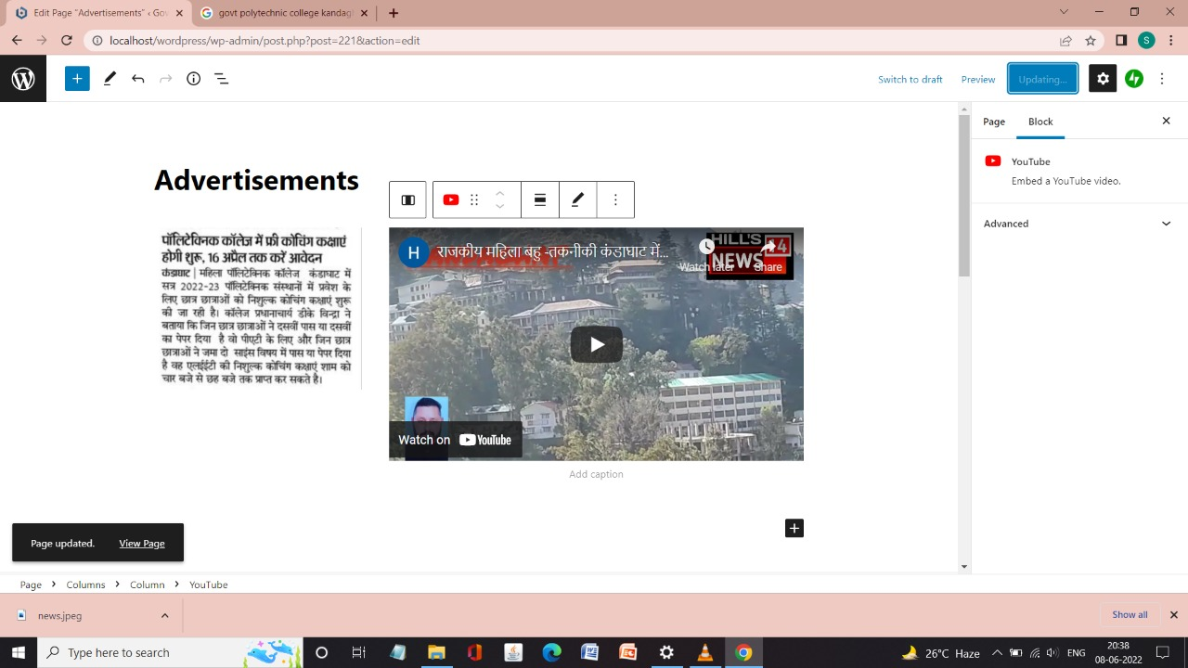

**Fig.2.3.7b**

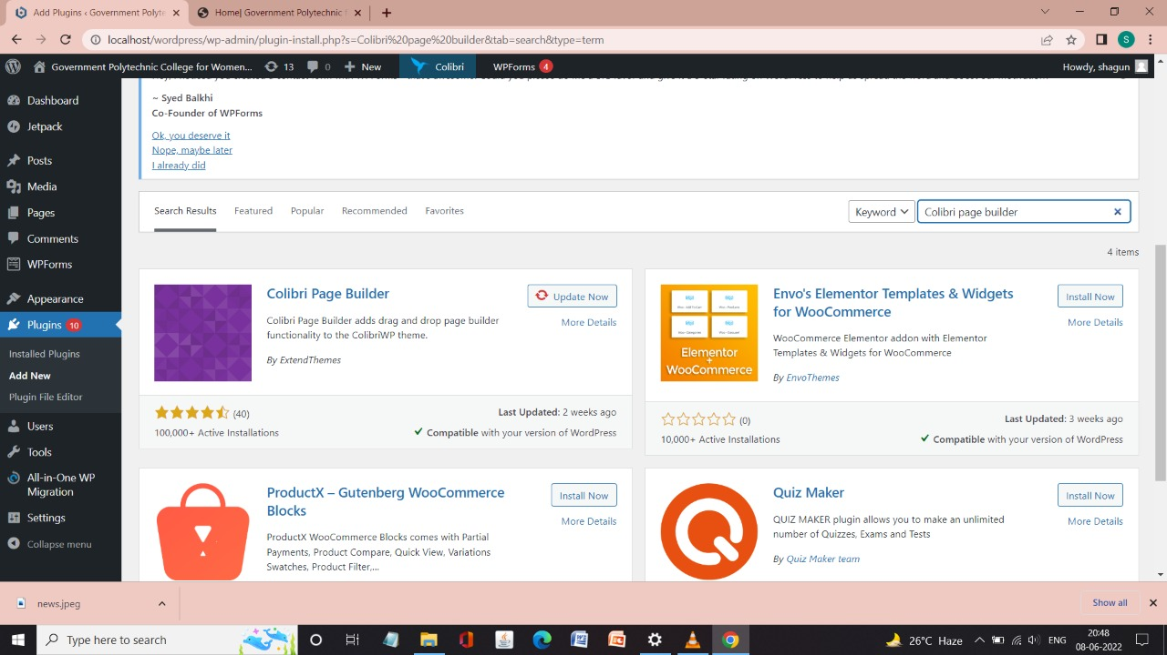**8. Here how we had install our plugins:**

**Fig.2.3.8**

**9. The one in blue color written activate are all the installed plugins:**

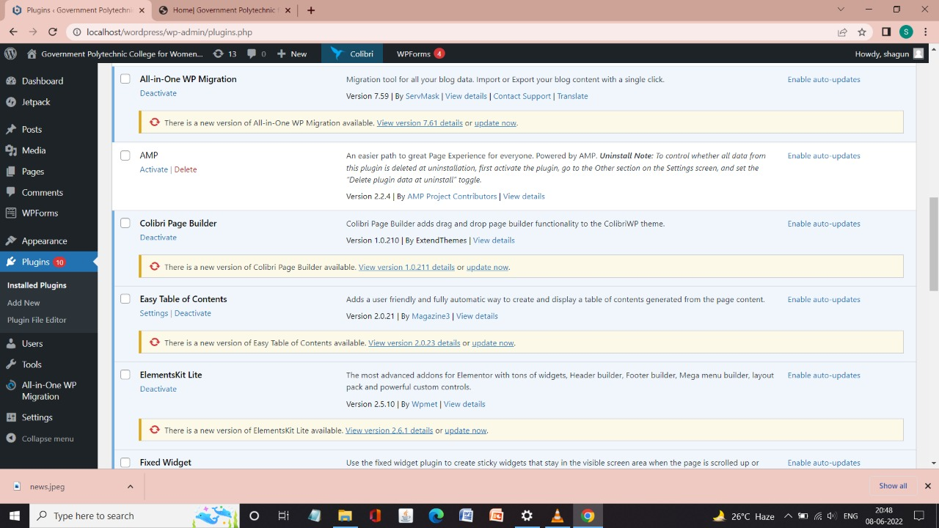

**Fig.2.3.9a**

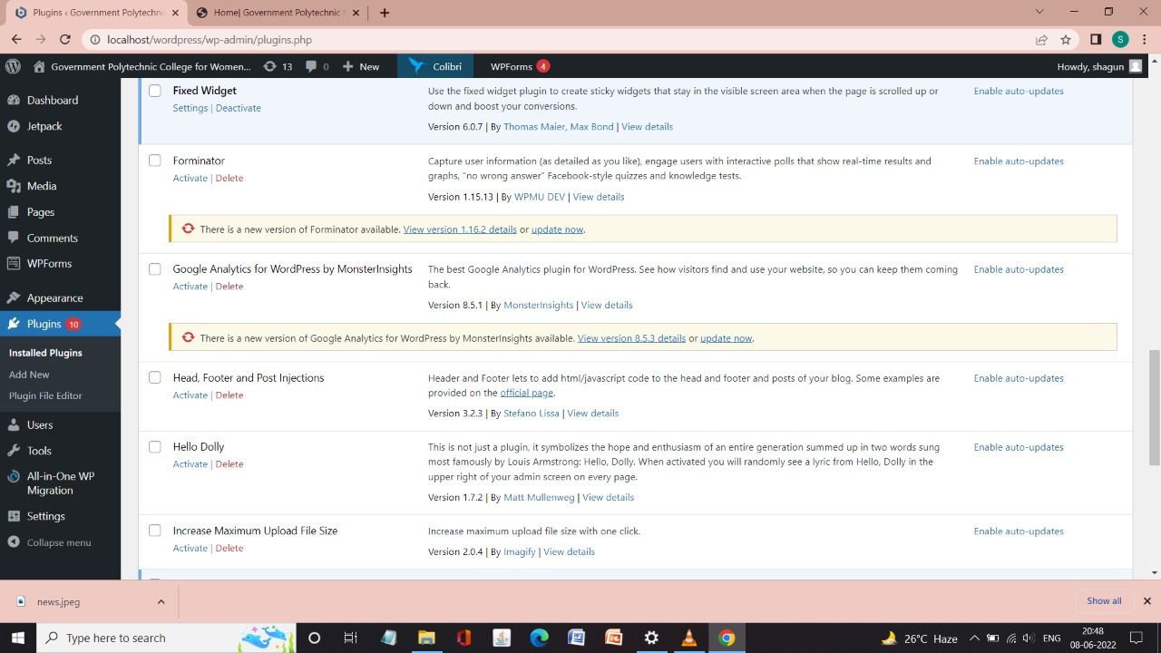 **Fig.2.3.9b**

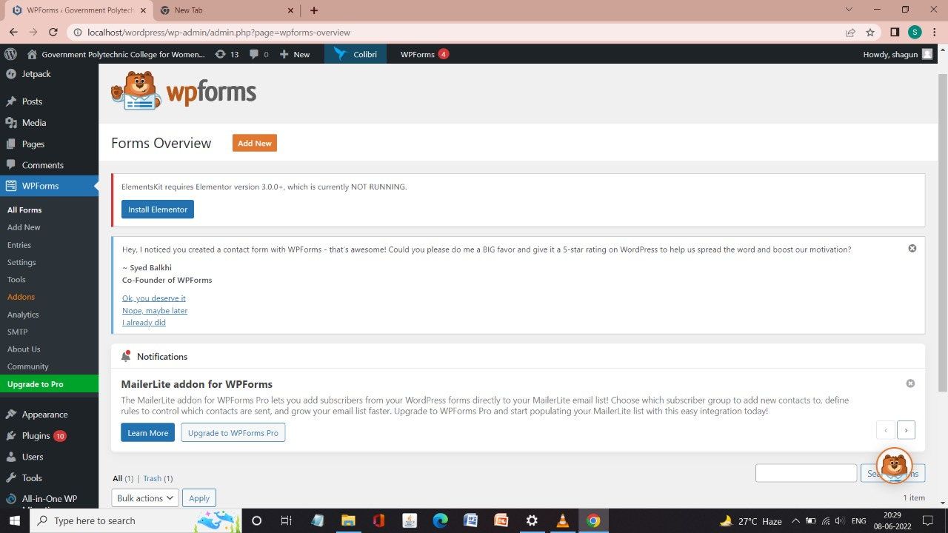**10. This is the plugin installed to create forms to our website:**

**Fig2.3.10**

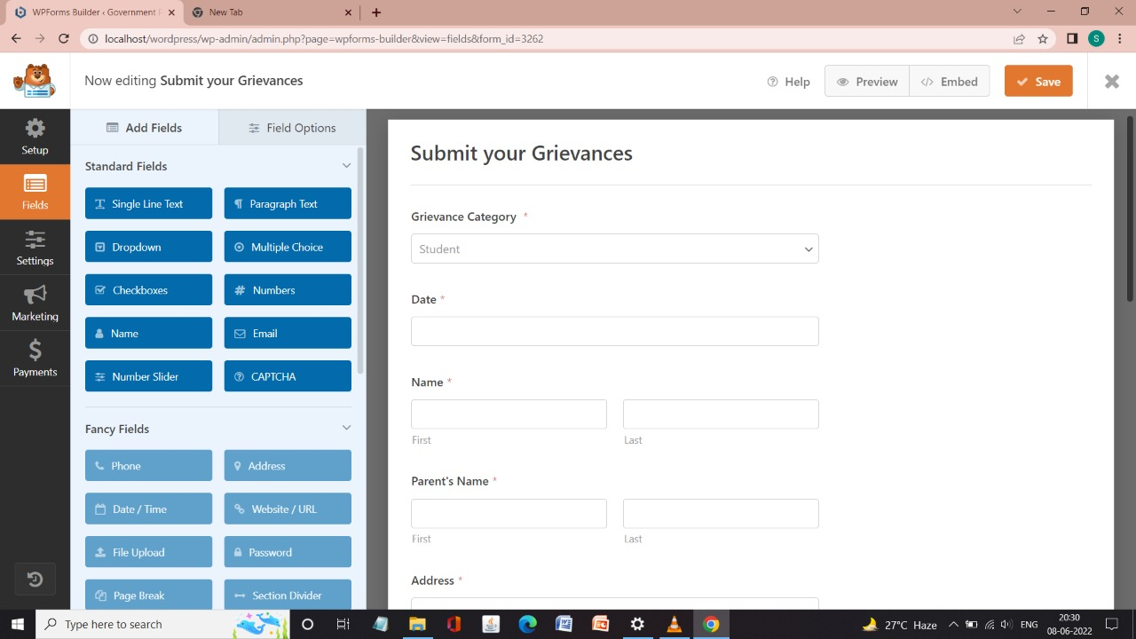

**Fig.2.3.10b**

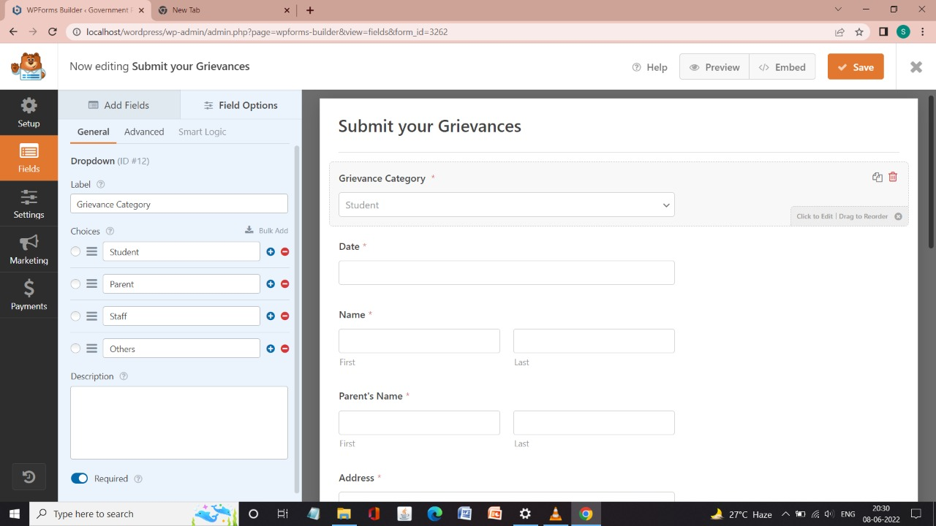

**Fig.2.3.10c**

**12. Word press software has its own command prompt as well as its database:**

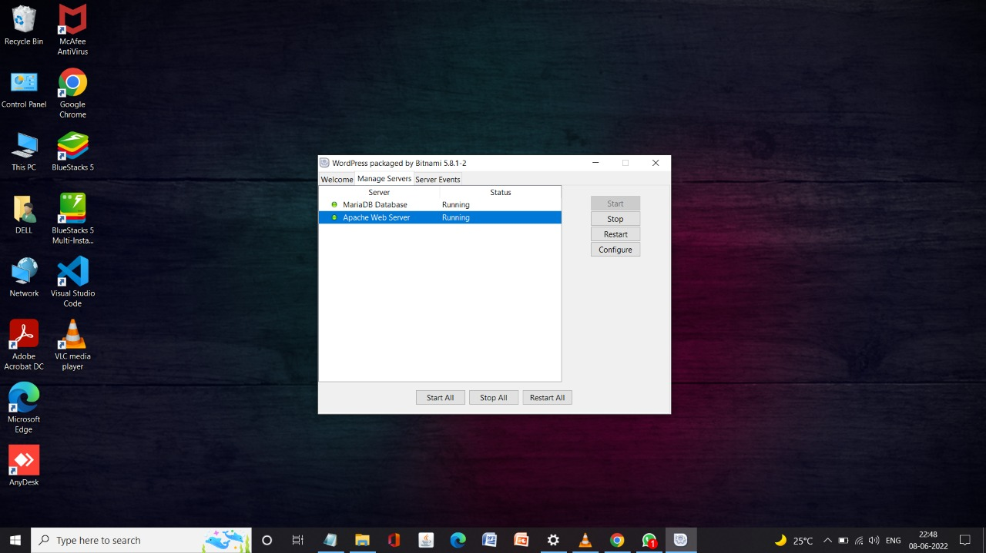

**Fig.2.3.12a**

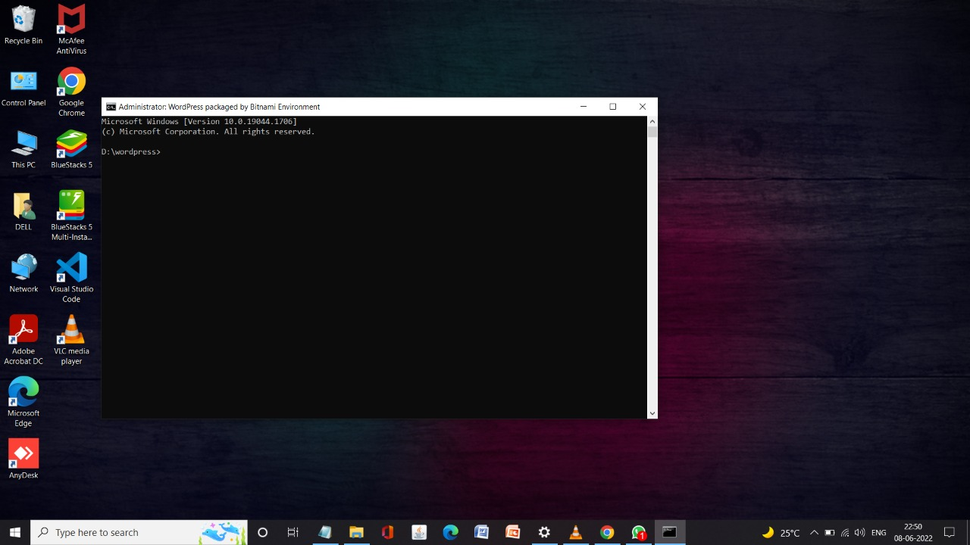

**Fig.2.3.12b**

**13. This is the reusable section attached to the site that we have saved for further use:**

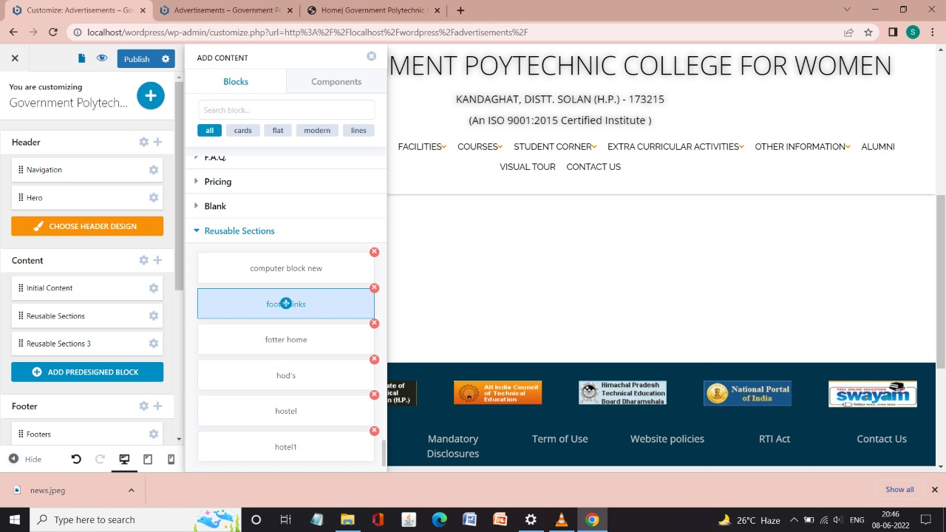

**Fig.2.3.13**

**CHAPTER – 3**

**PROJECT DESIGN**

**3.1 INTRODUCTION:**

In this process of developing specifications for a candidate system that meet the criteria established in the system analysis. The plan of project provides a review of the different modules in which the project is divided.

**3.2 DETAILED DESIGN:**

**3.2.1 Sitemap**

HOME PAGE

OTHER INFORMATIONON

ABOUT US

COURCES

VISUAL TOUR

STUDENT CORNER

EXTRA CURRICULAR ACTIVITIES

FACILITIES

CONTACT US

FACULTY STAFF

ALUMNI

**3.2.2 WEBSITE DESIGN:**

**1.**

USER

HOME PAGE

AICTE EOA

INSTITUTE

SCHEMES

RTI ACT

**2.**

HOME PAGE

USER

**3.**

HOME PAGE

USER

CENTRAL LIBRARY

HOSTEL

**4.**

HOME PAGE

USER

COMPUTER ENGG.

5.

HOME PAGE

USER

ACHIEVEMENTS

EVENTS

**6.**

USER

HOME PAGE

MANDATORY DISCLOSURES

ADVERTISEMNETS

T&P CELL

ANTI-RAGGING

GRIVIENCES

7.

HOME PAGE

USER

RESULTS

INTERNAL SESSIONAL

ACADEMIC CALENDAR

TIME TABLE

LESSON PLANS

8.

HOME PAGE

USER

9.

HOME PAGE

USER

10.

HOME PAGE

USER

**CHAPTER - 04**

**PROJECT IMPLEMETATION**

**4.1 INTRODUCTION:**

Implementation is the stage in the project where the theoretical design is turned into the working system and is giving confidence to the new system for the users i.e. will work efficiently and effectively. It involves careful planning, investigation of the current system and its constraints on implementation, design of method to achieve the changeover, an evaluation, of change over methods. Apart from planning major task of preparing the implementation is education of users.

**4.2 SITE DEVELOPMENT:**

**4.2.1 SNAPSHOT OF WEBSITE:**

**1. HOME PAGE:**

This is the main page of our website which contains further pages in it.

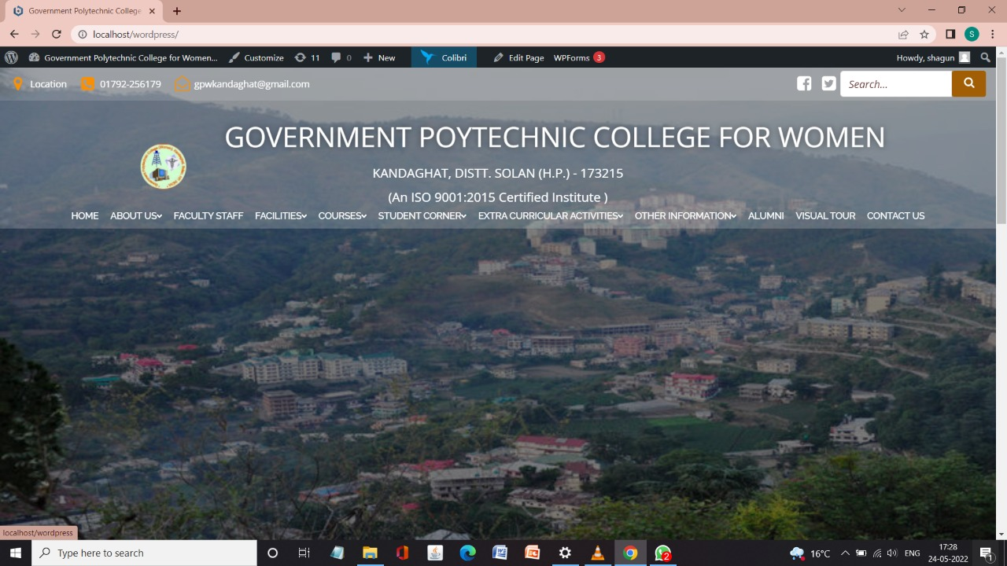

**Fig4.1**

**2. ABOUT US:**

This page will contain information about institute, schemes, AICTE, and about RTI act offered in our college.

INSTITUTE:

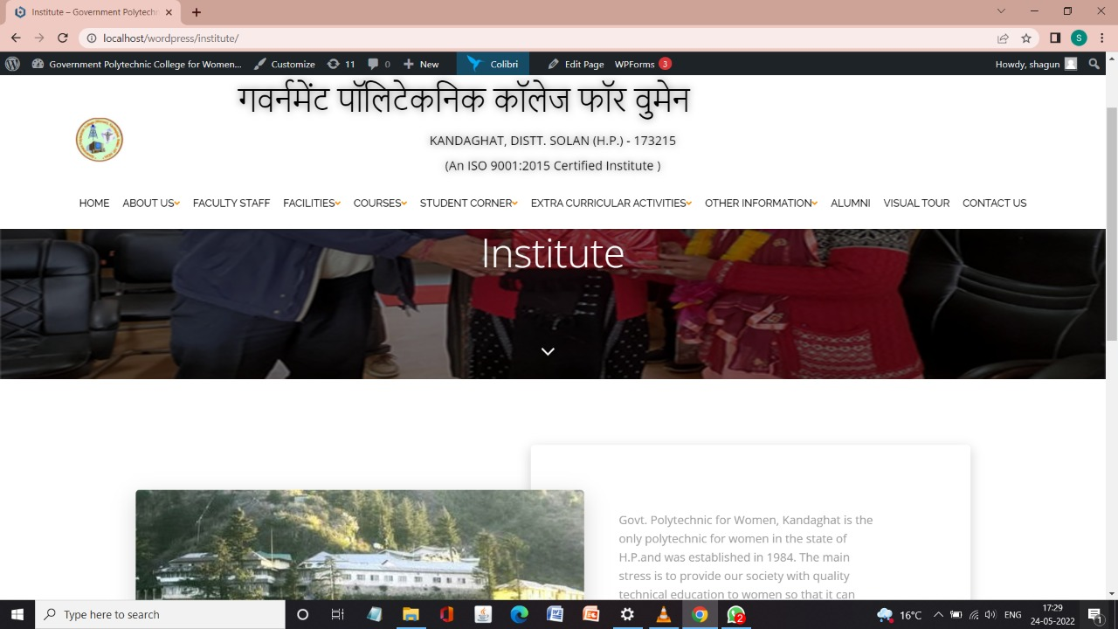

RTI ACT:

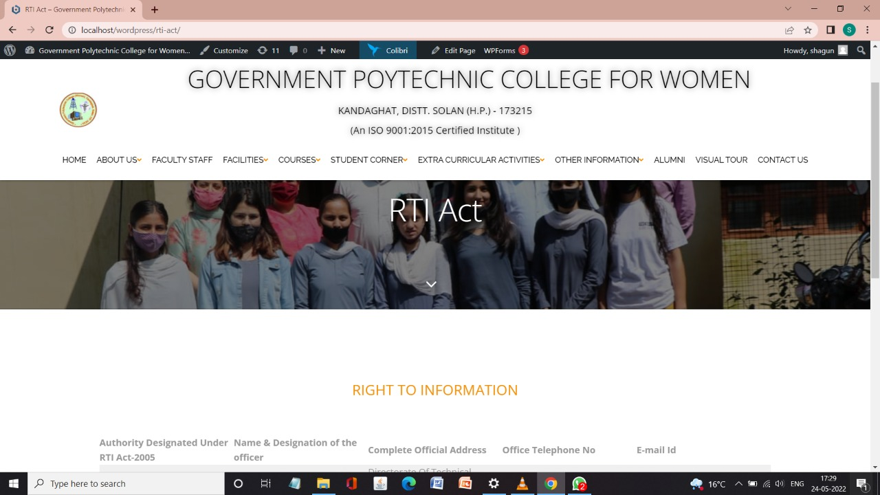

**Fig4.2.2**

SCHEMES:

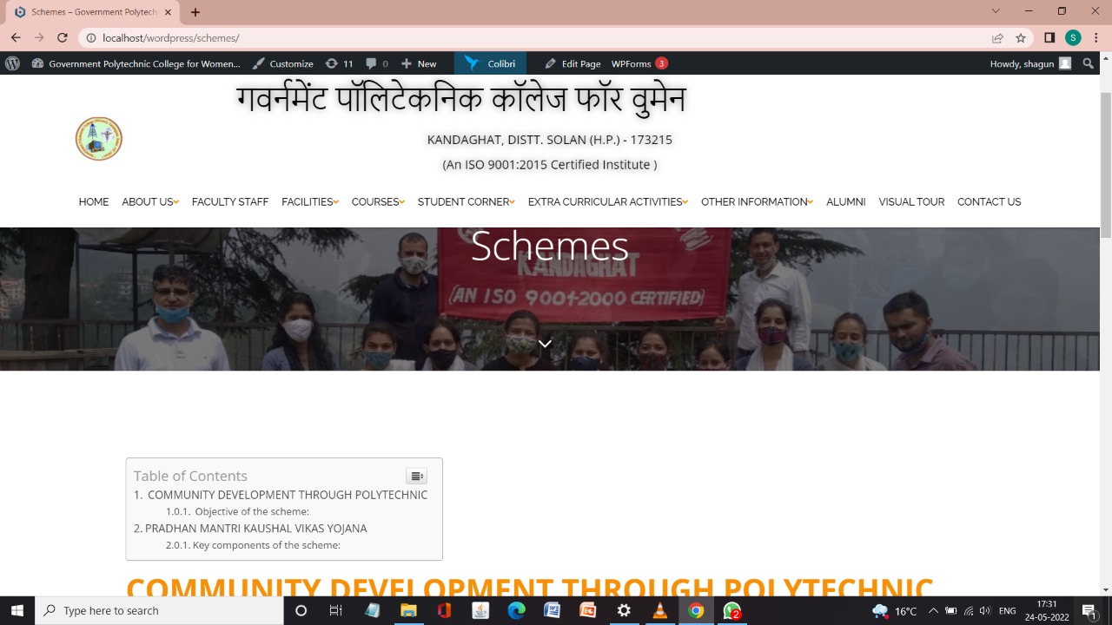

**Fig4.2.3**

AICTE EOA:

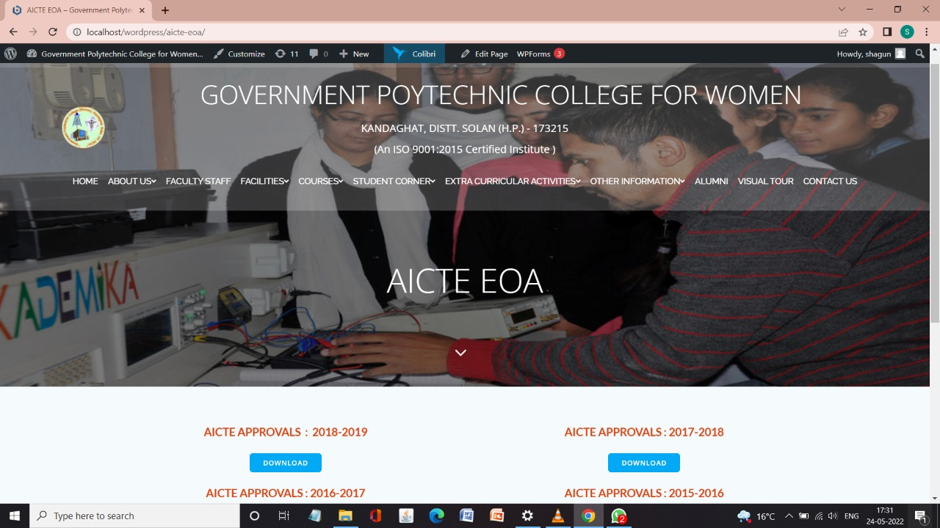

**Fig.4.2.4**

**3. FACULTY STAFF:**

This page contains about all the faculty members of our institute teaching the students of particular trade taught in the institute and all the staff members working in the institute in various fields such as clerks, stenos, cleaning, maintenance etc.

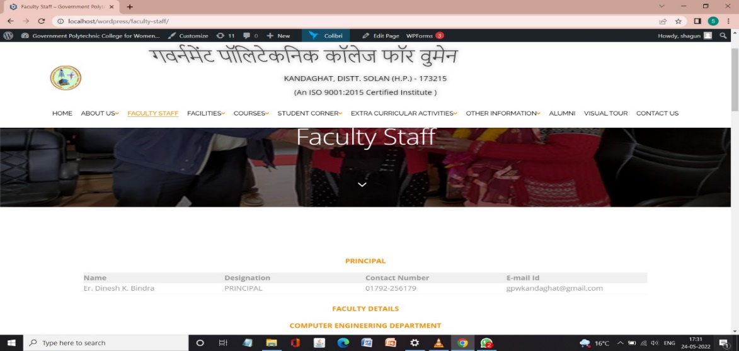

**Fig4.3.1**

**4. FACILITIES:**

In this page it will contain facilities that are provided by our college such as central library and hostel facilities**.**

CENTRAL LIBRARY:

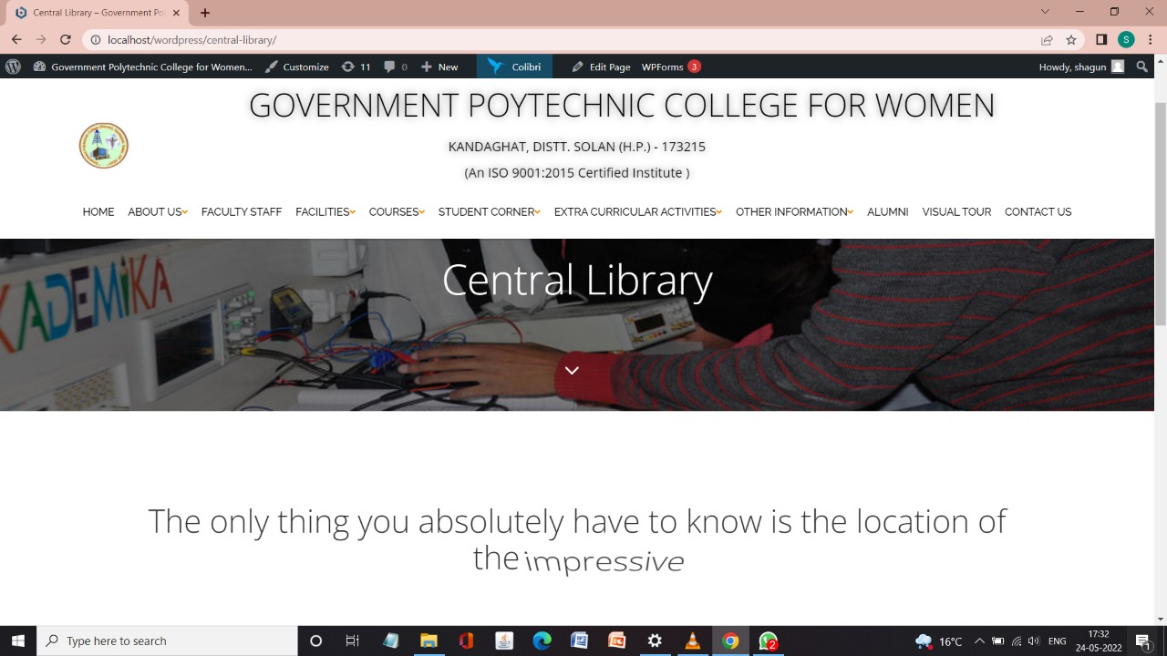

**Fig.4.4.1**

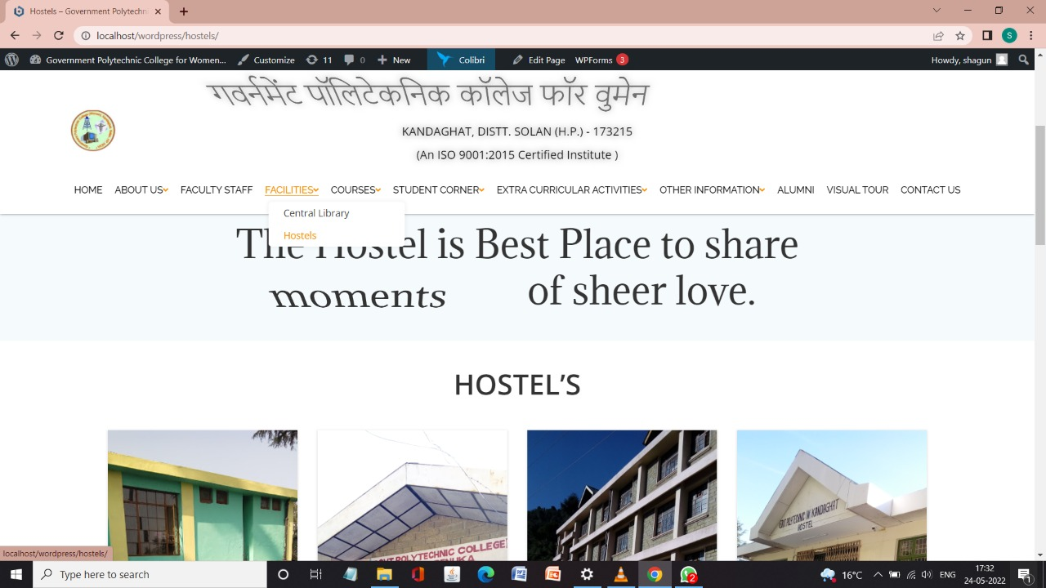HOSTELS :

**Fig.4.4.2**

**5. COURSES:**

This page contains about the courses offered by our institute.

COMPUTER ENGINEERING:

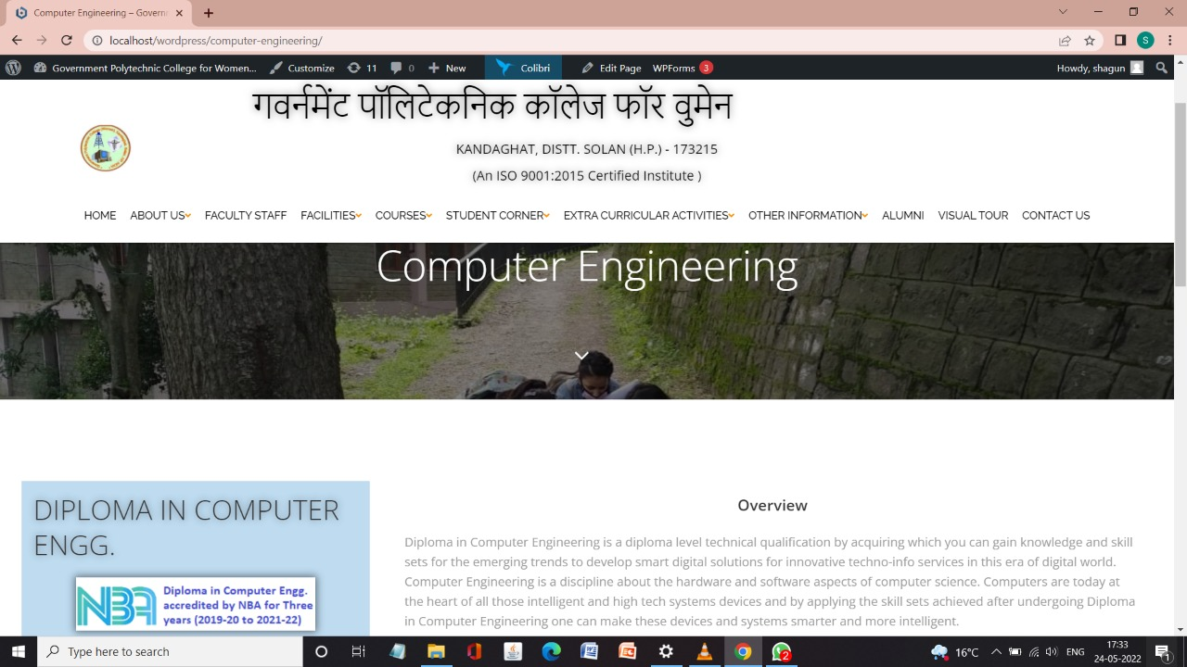

**Fig.4.5.1**

**6. STUDENT CORNER:**

This contains about all the necessary information about the students like their academic calendar, results, attendance, syllabus etc.

TIME TABLE:

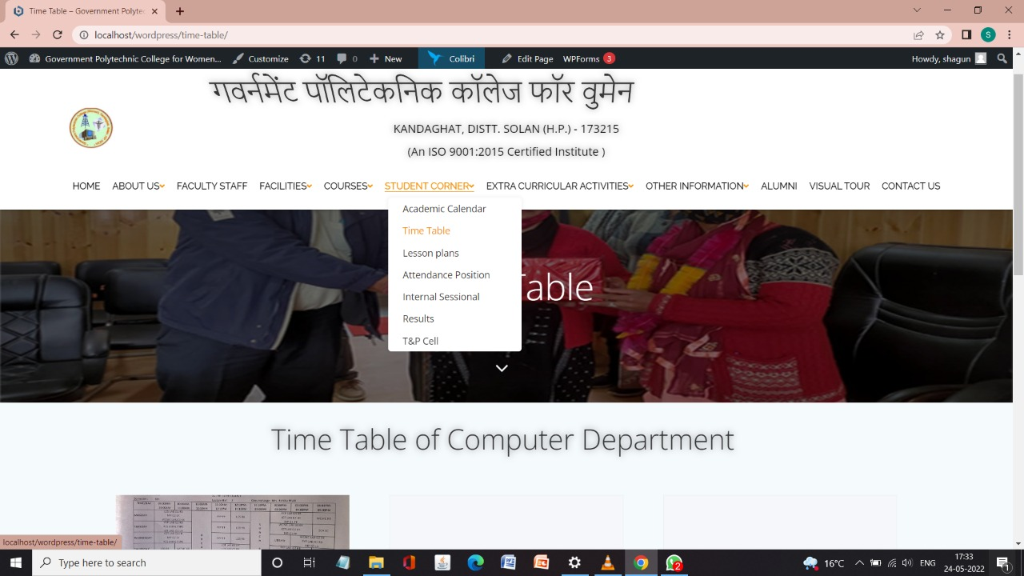

**Fig.4.6.1**

ACAMEDIC CALENDAR:

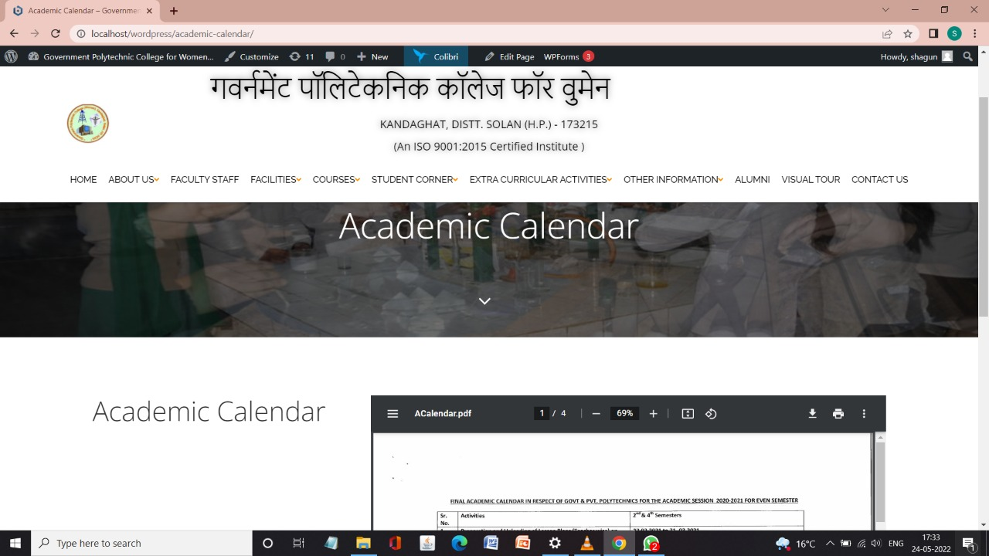

**Fig.4.6.2**

LESSON PLANS:

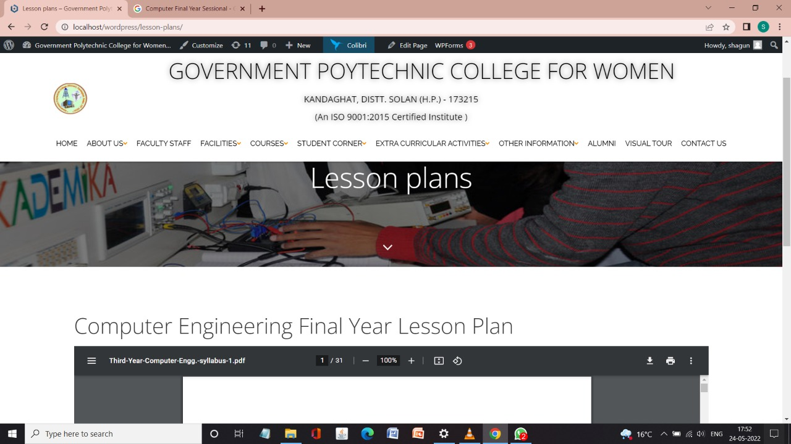

**Fig.4.6.3**

INTERNAL SESSIONAL:

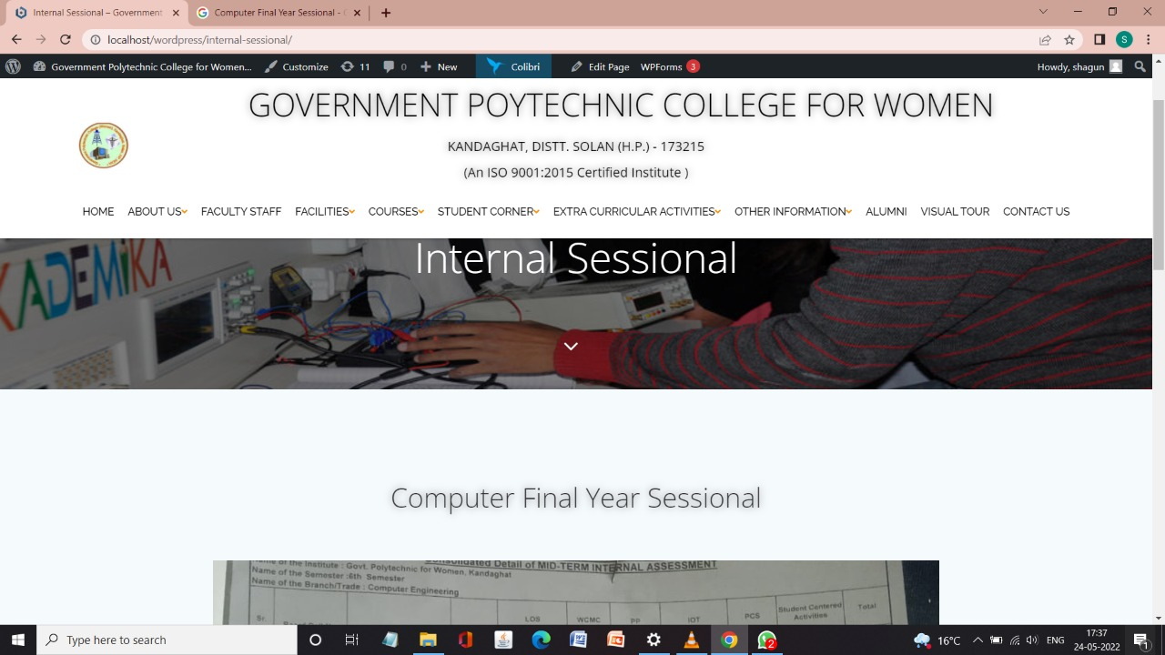

**Fig.4.6.4**

RESULTS:

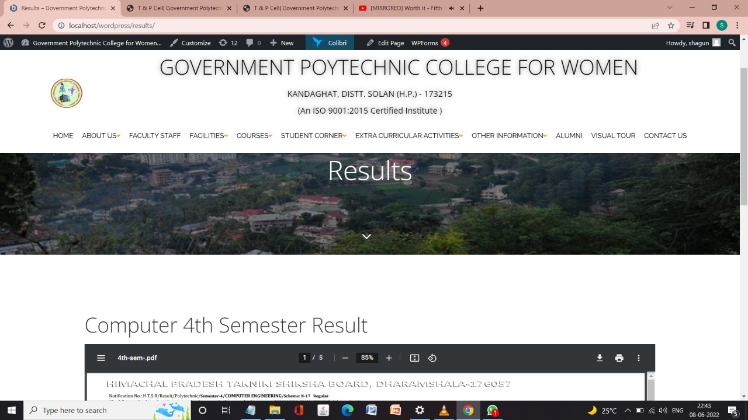

**Fig.4.6.5**

**7. EXTRA CURRICULAR ACTIVITIES:**

This page contains about the events performed in our college such as Environment Day celebration, Slogan writing, dancing competition, Singing competition, Declarations and many more. It also contains about achievements of our college in various fields,

ACHIEVEMENTS:

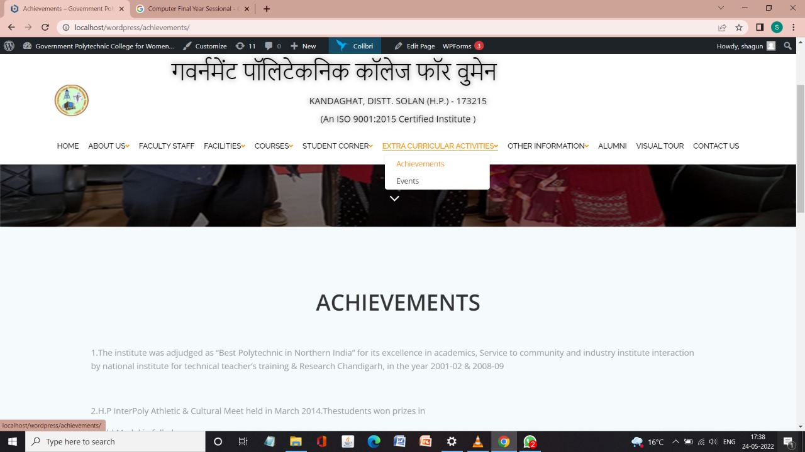

**Fig4.7.1**

EVENTS:

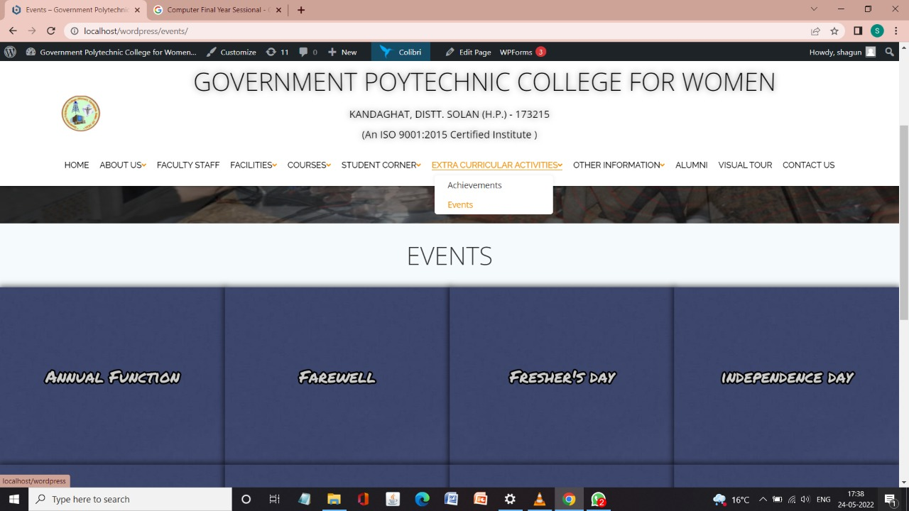

**Fig.4.7.2**

**8. OTHER INFORMATION:**

This page contains about the advertisements, notice or mandatory disclosures posted by institute.

MANDATORY DISCLOSURES:

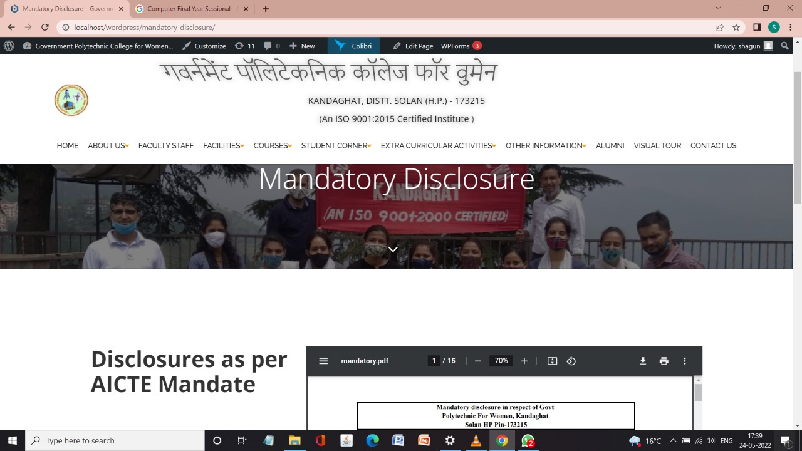

**Fig.4.8.1**

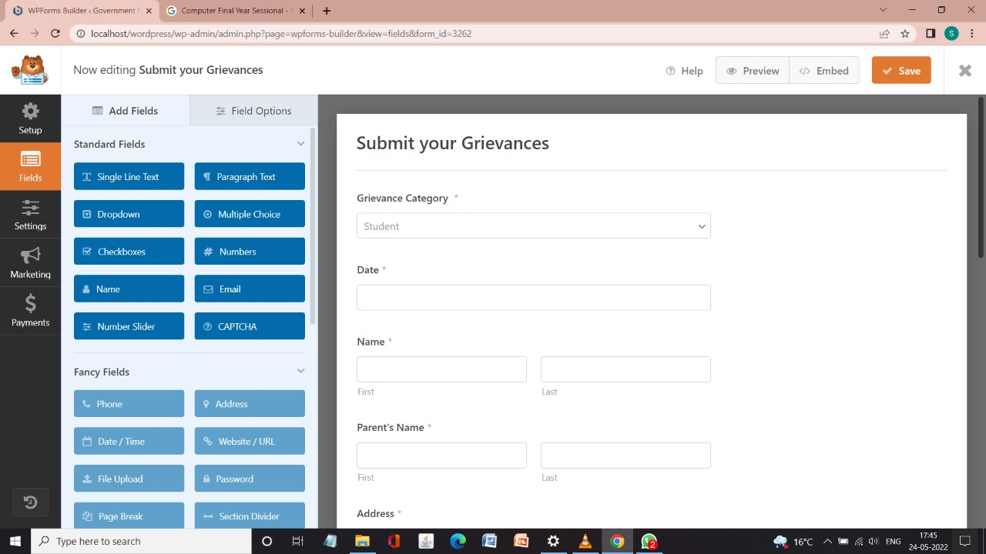GRIVIENCES:

**Fig.4.8.2**

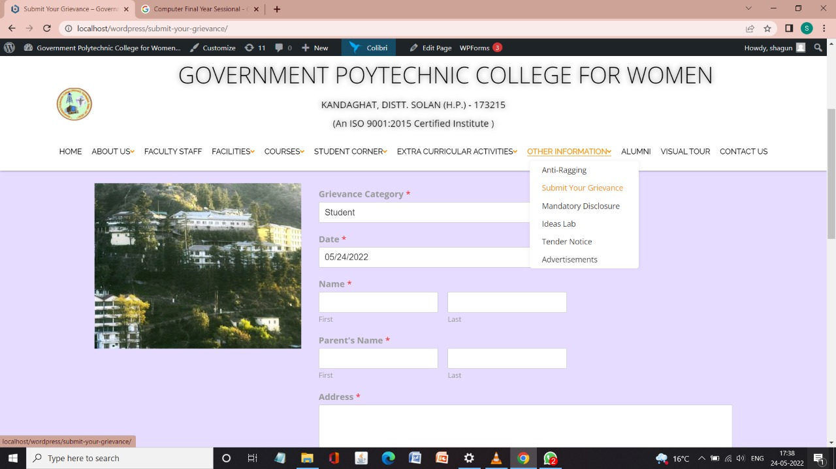

**Fig.4.8.3**

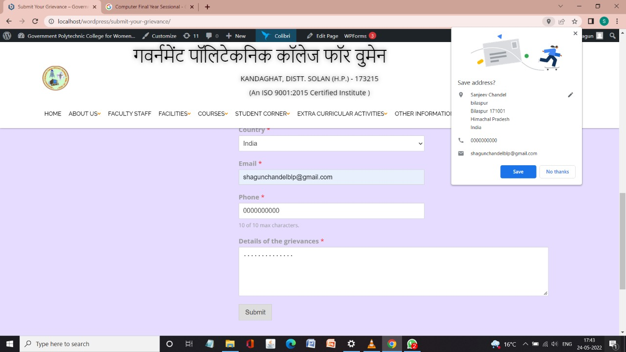

**Fig.4.8.4**

ANTI RAGGING:

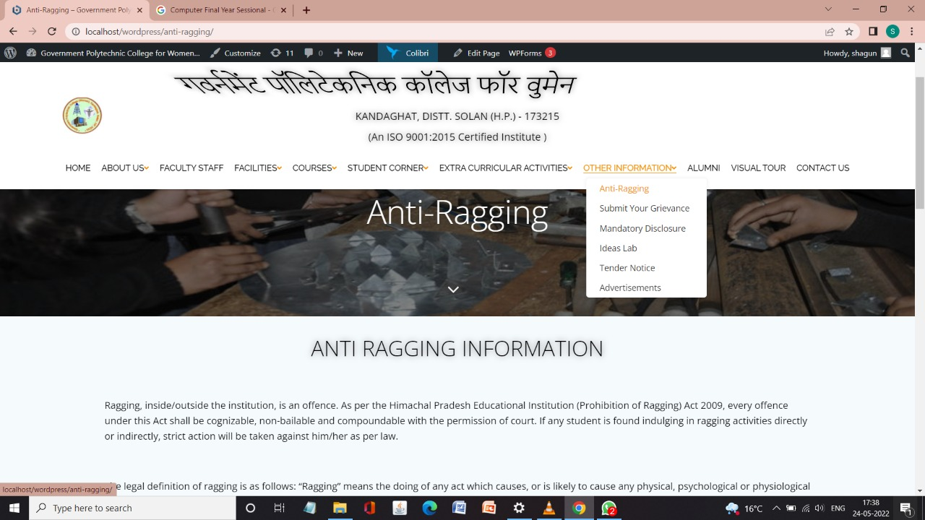

**Fig4.8.5**

T&P CELL:

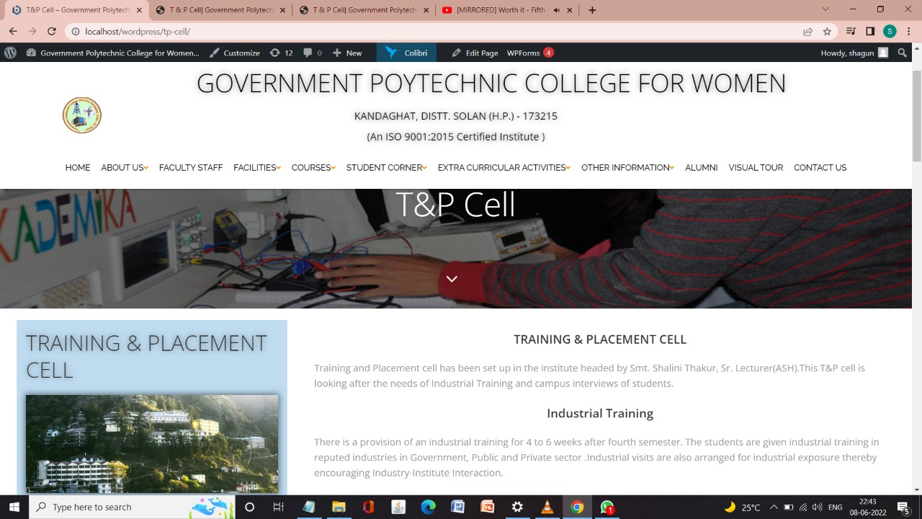

**Fig.4.8.6**

ADVERTISEMENTS:

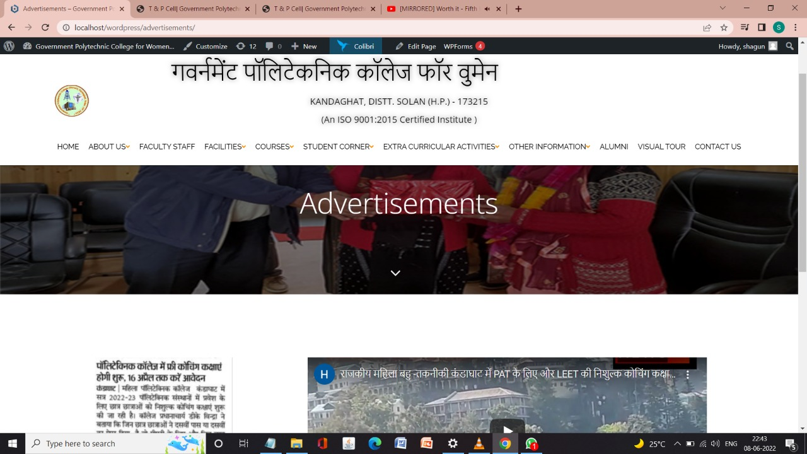

**Fig.4.8.7**

TENDER NOTICE:

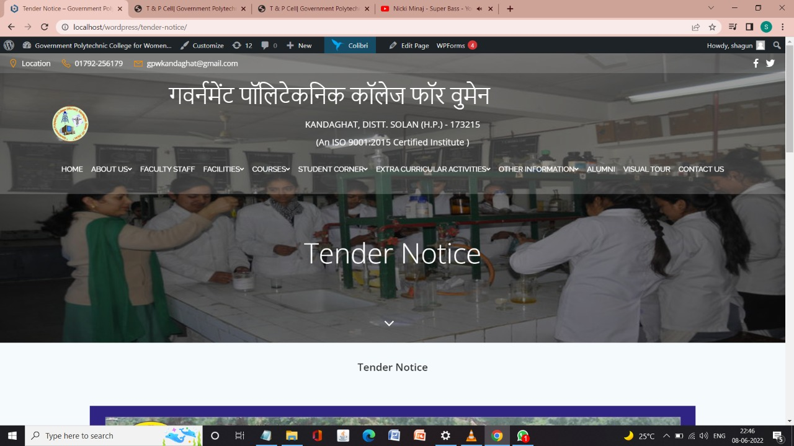

**Fig.4.8.8**

**9. ALUMNI:**

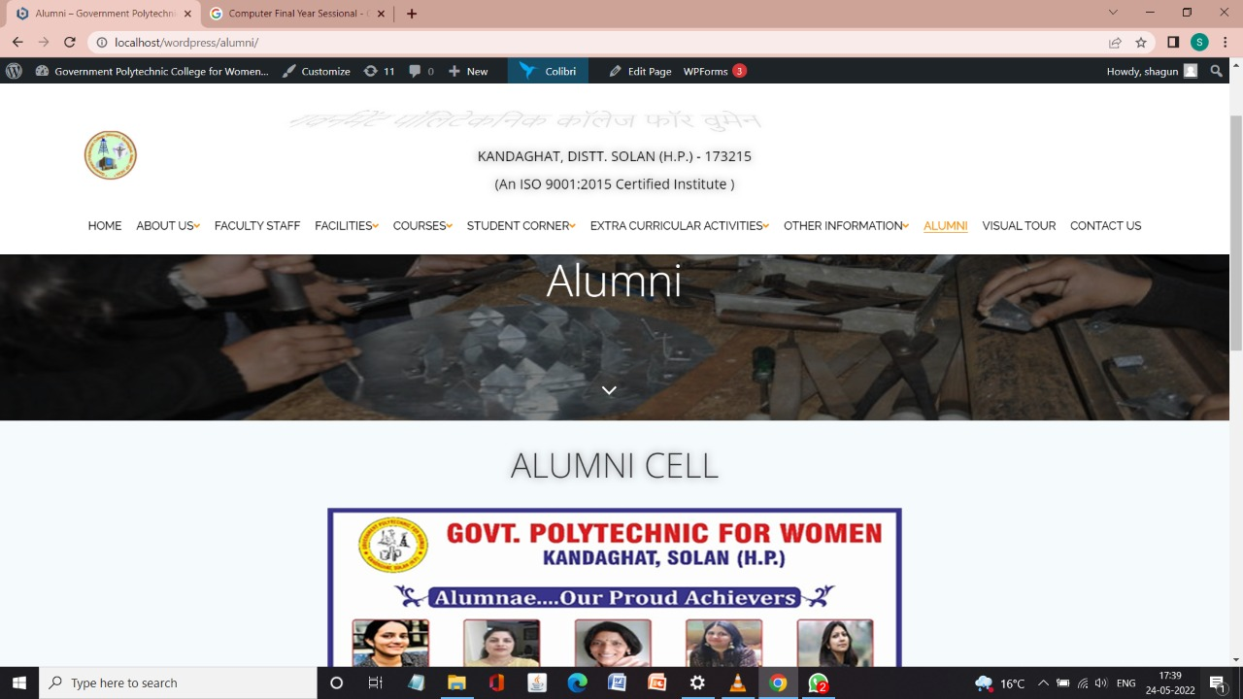This page contains about all the proud Alumnae of our college. These students have achieved the success in their fields and had made our college project.

**Fig4.9.1**

**10. VISUAL TOUR:**

This page contains a visual tour of our college.

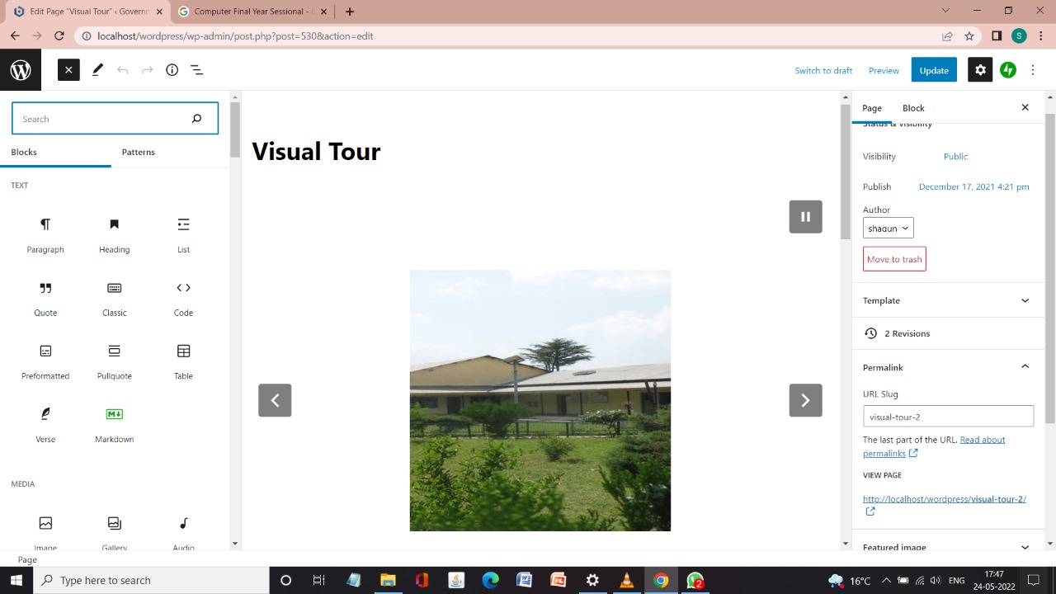

**Fig.4.10.1**

**11. CONTACT US:**

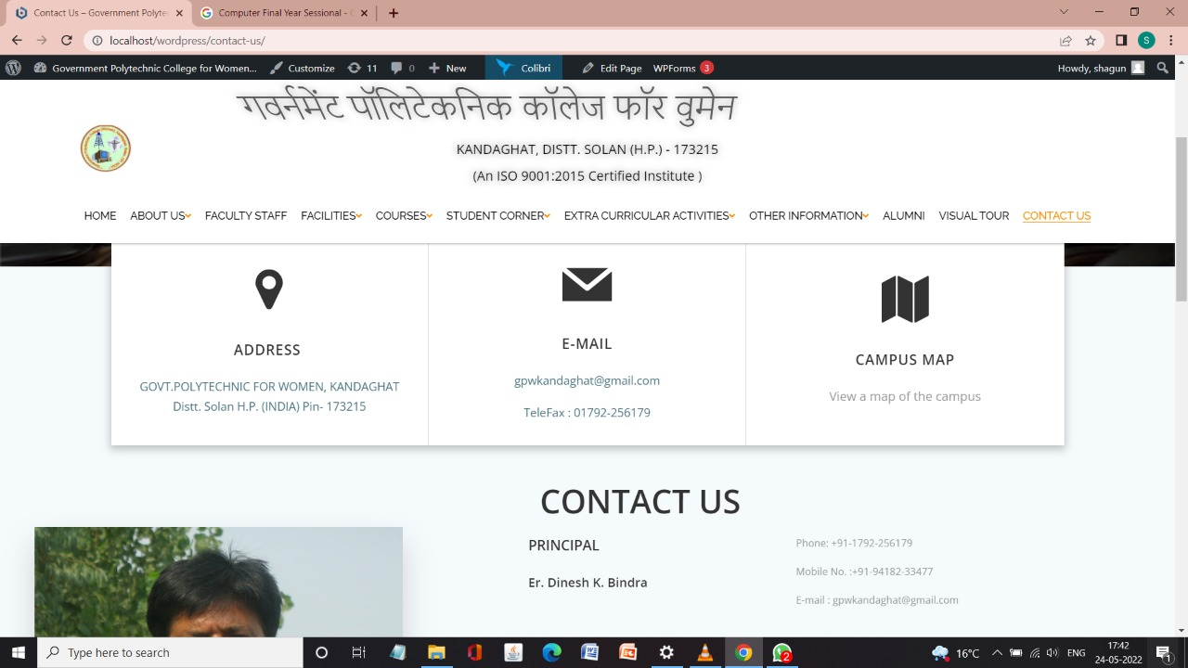This page contains the contacts of our Principal Sir, all the HOD’s of various trade and necessary contact required.

**Fig.4.11.1**

**12 HEADER PART OF THE WEBSITE:**

SEARCH:

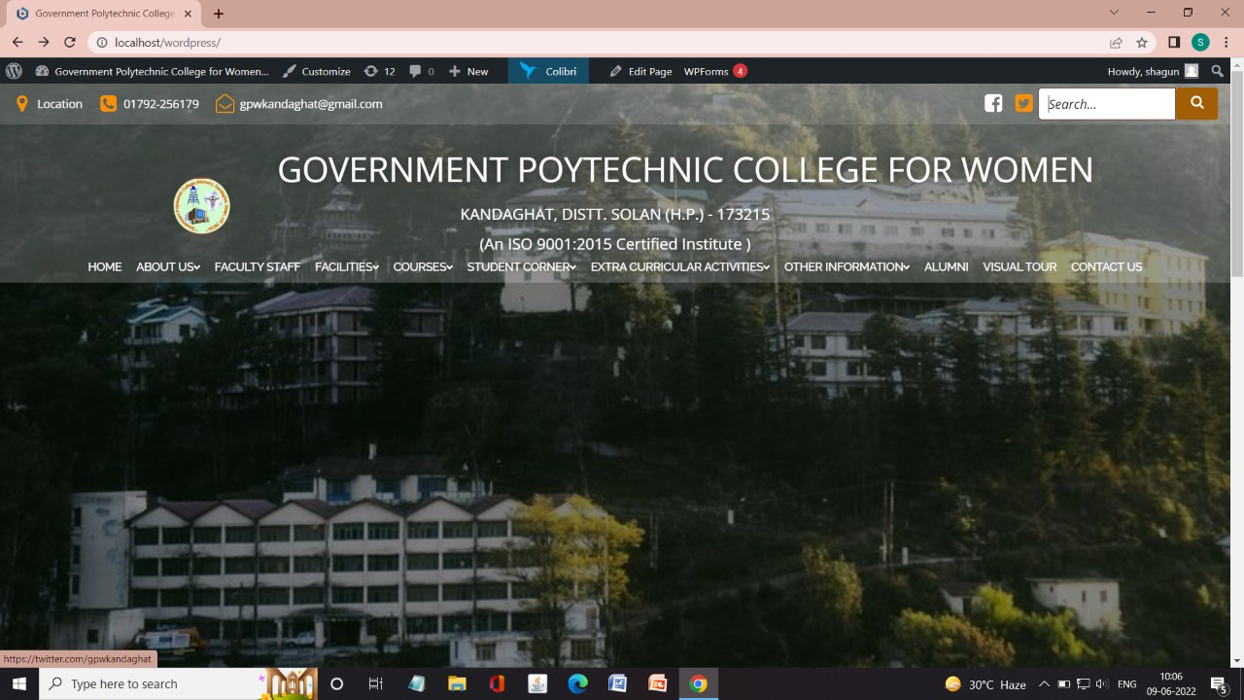

**Fig.4.12.1a**

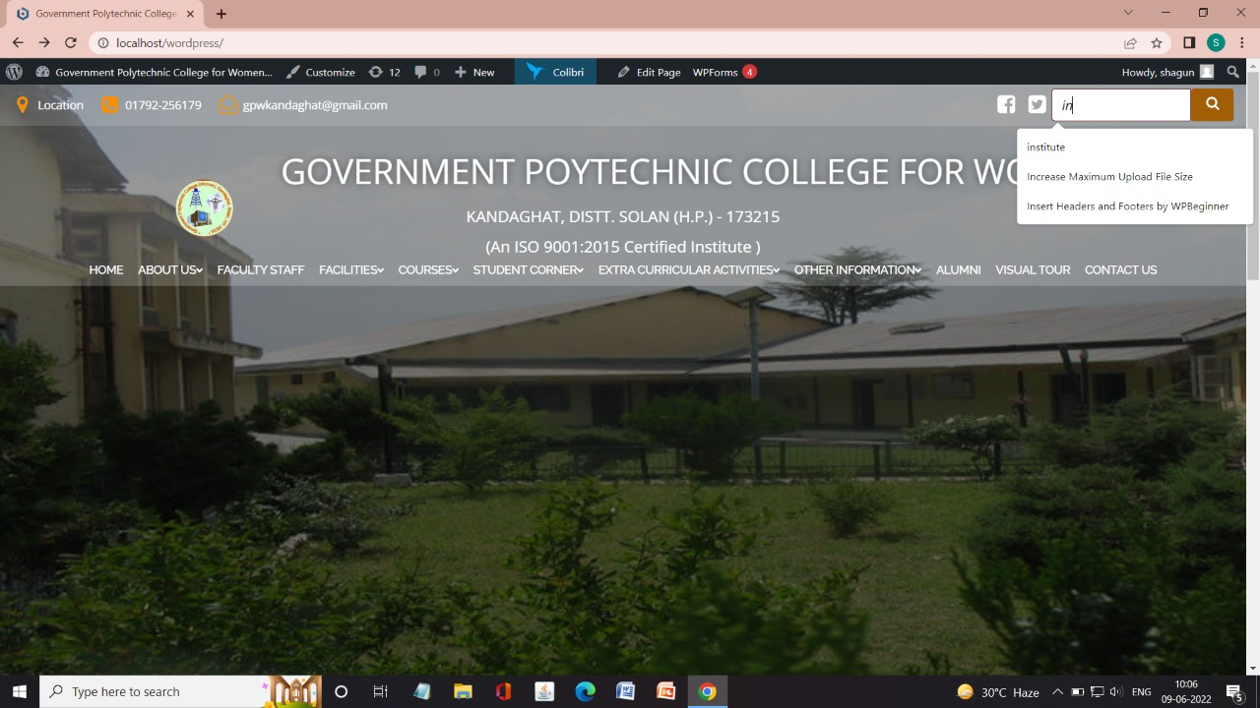

**Fig.4.12.1b**

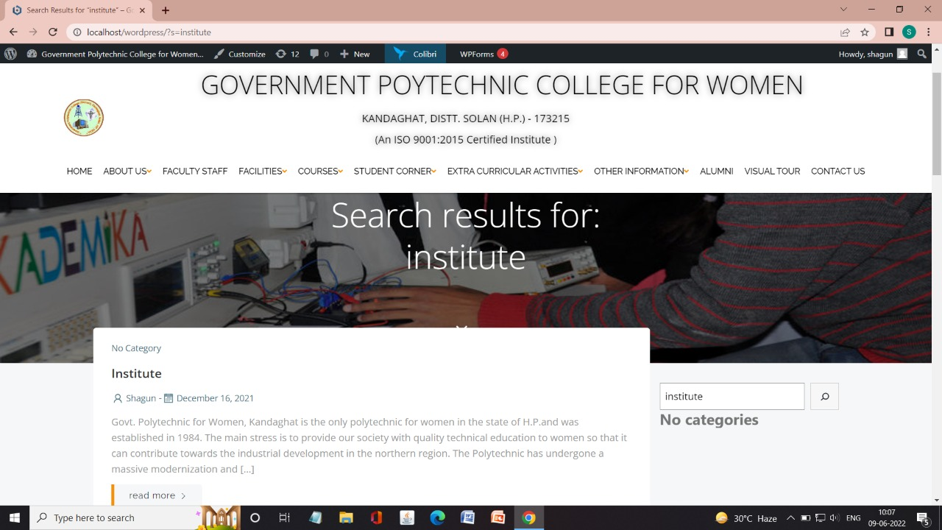 **Fig.4.12.1c**

TWITTER:

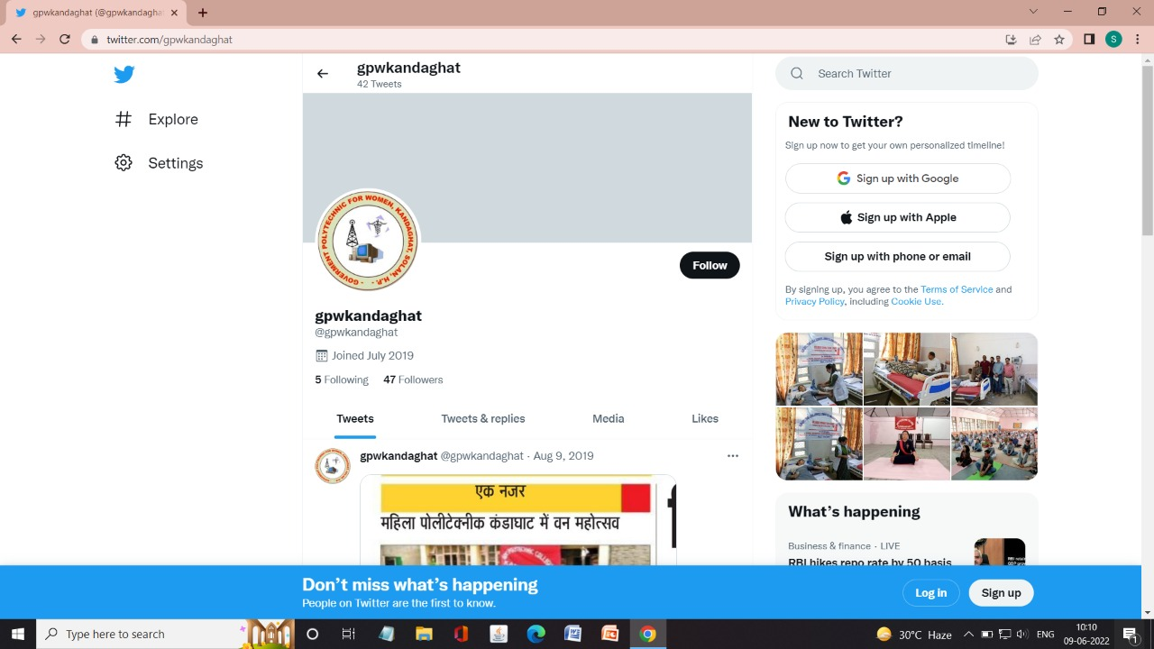

**Fig.4.12.2**

FACEBOOK:

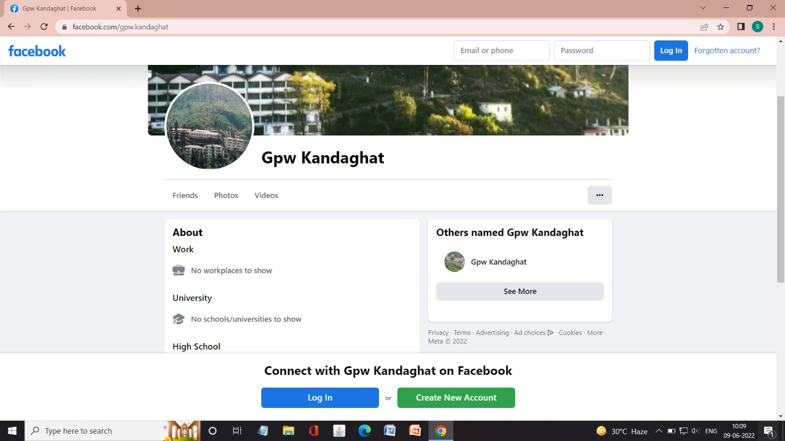

**Fig.4.12.3**

LOCATION:

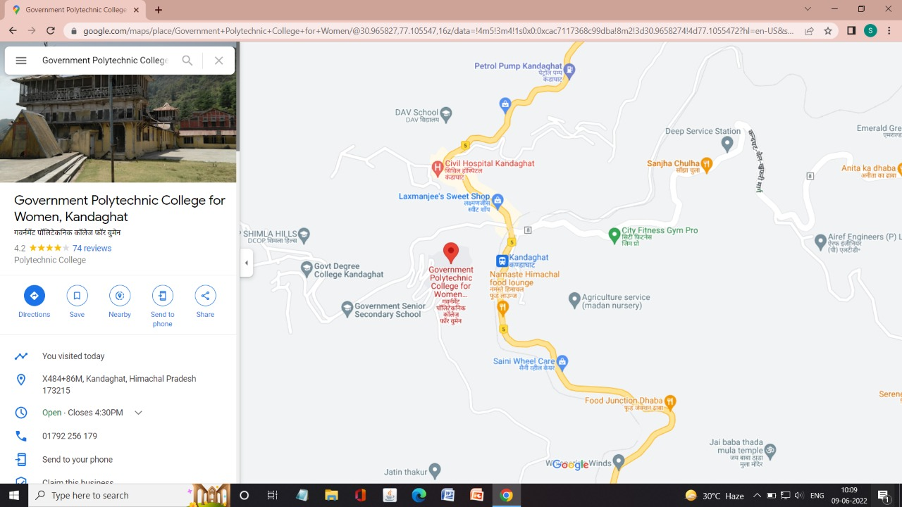

**Fig.4.12.4**

CONTACT:

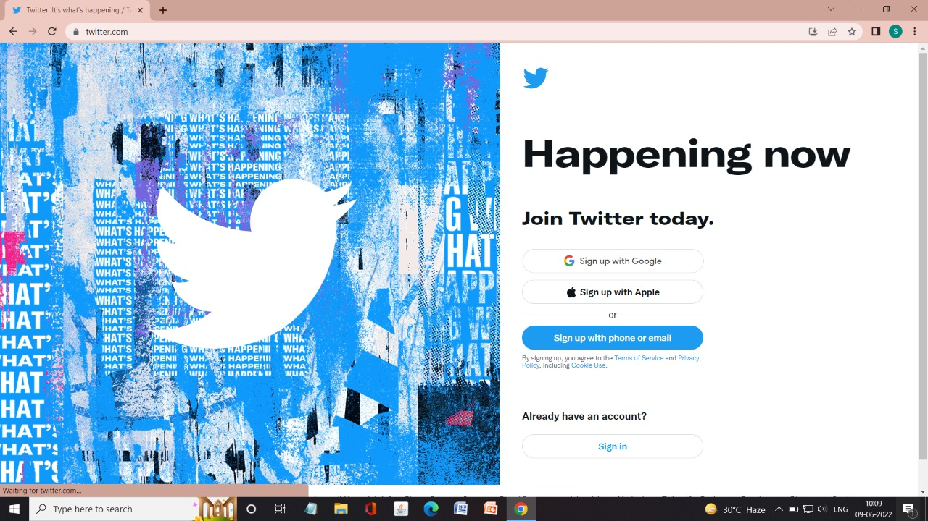

**Fig.4.12.5**

GMAIL:

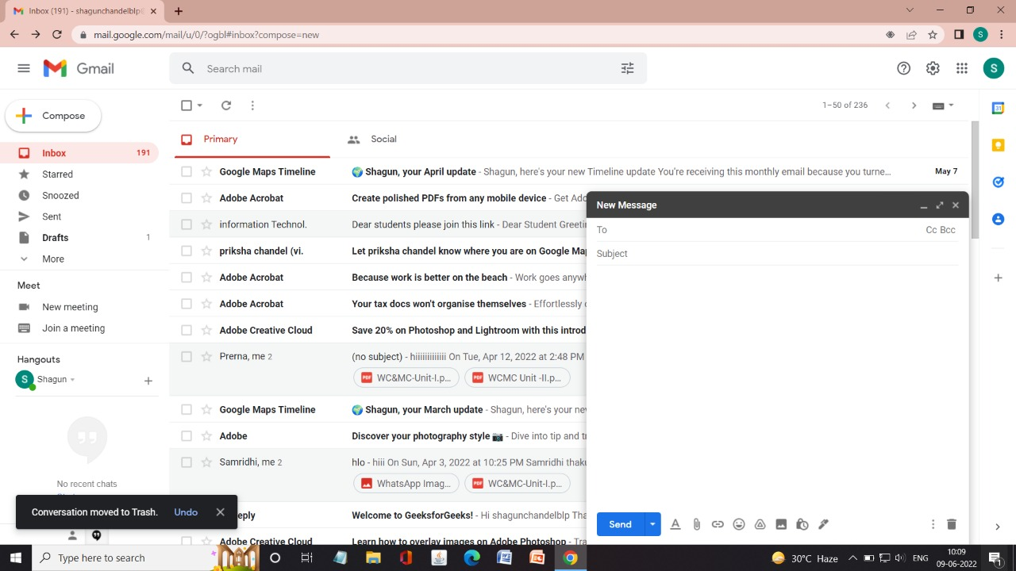

**Fig.4.12.6**

**13 FOOTER PART OF WEBSITE:**

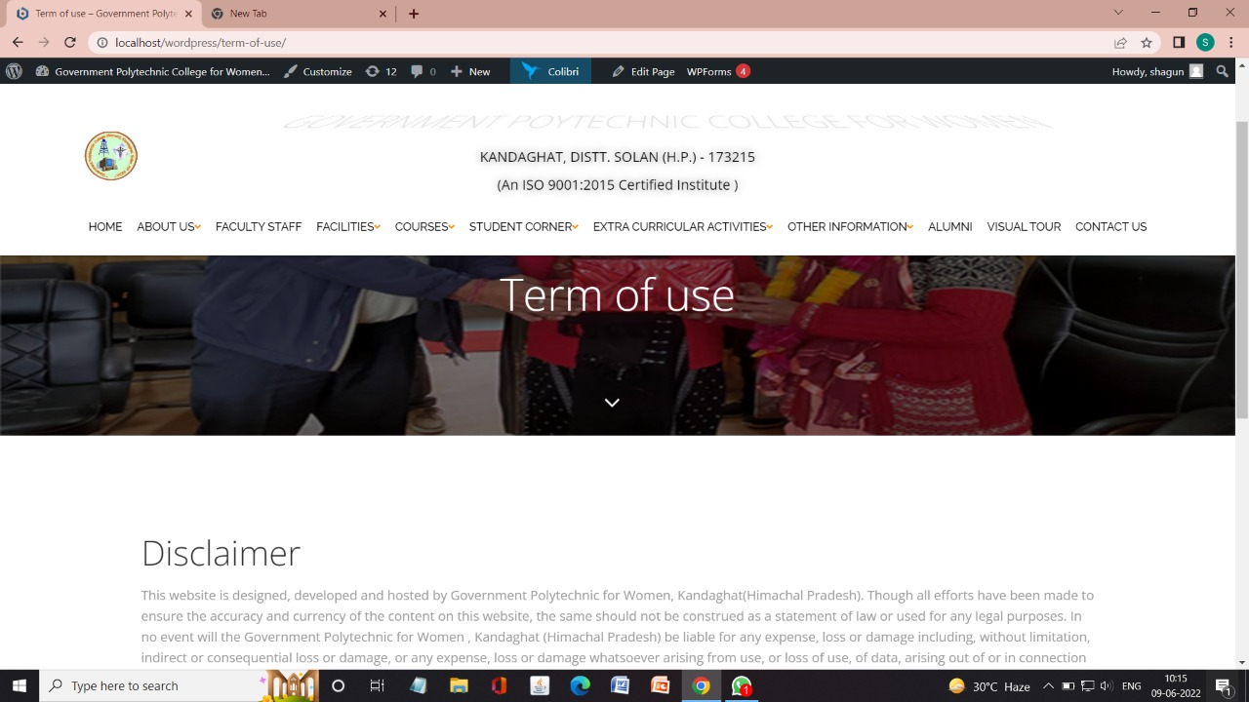TERMS OF USE:

**Fig.4.13.1**

WEBSITE POLICIES:

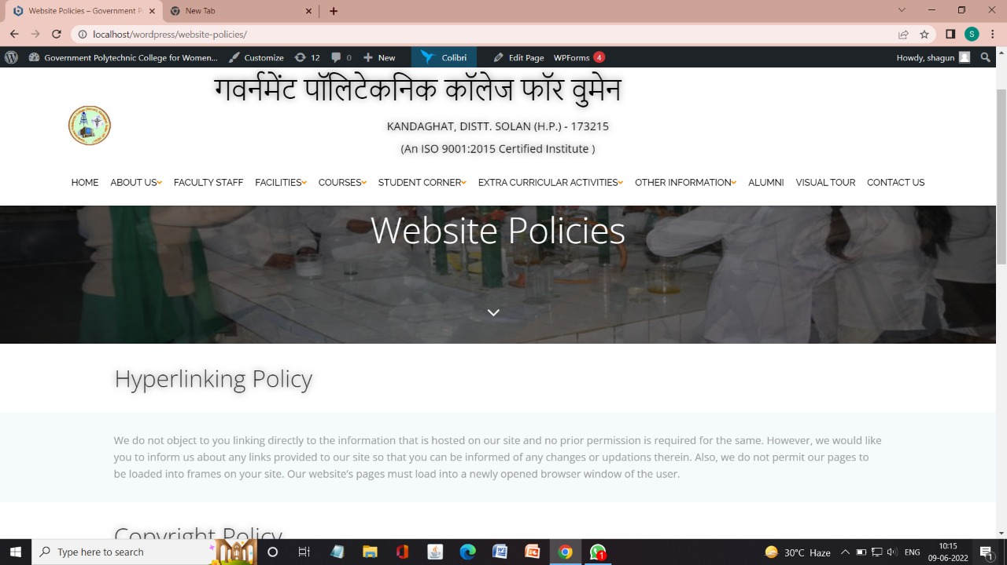

**Fig.4.13.2**

OTHER WEBSITE LINKS THROUGH OUR WEBSITE:

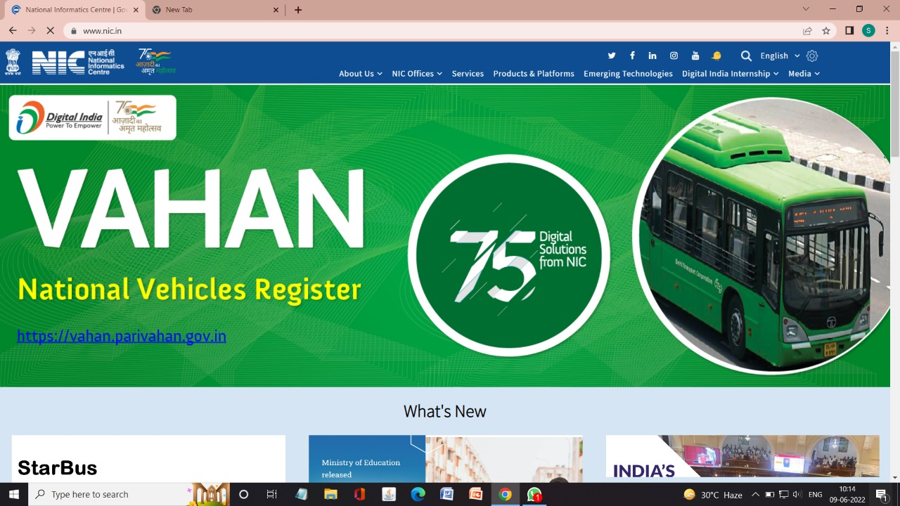

**Fig.4.13.2a**

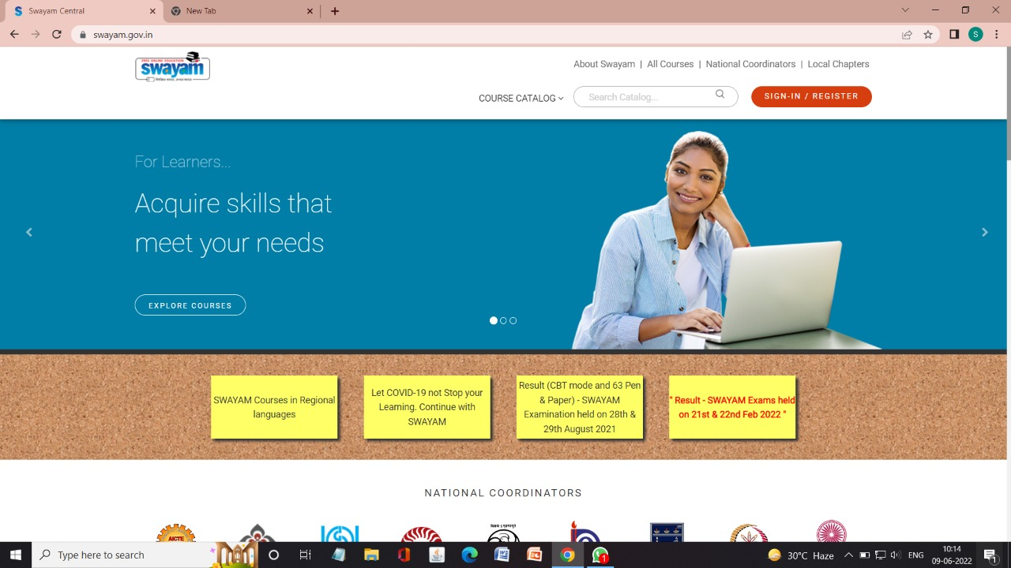

**Fig.4.13.2b**

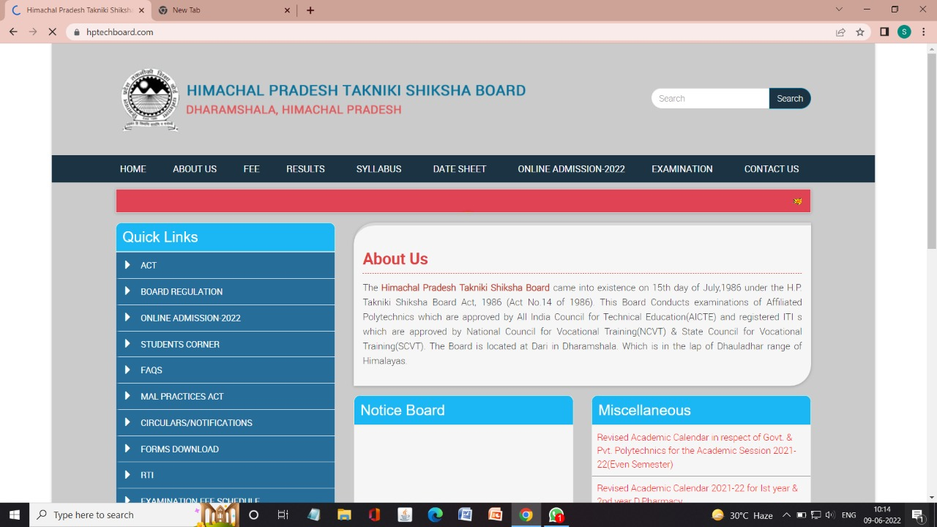

**Fig.4.13.2c**

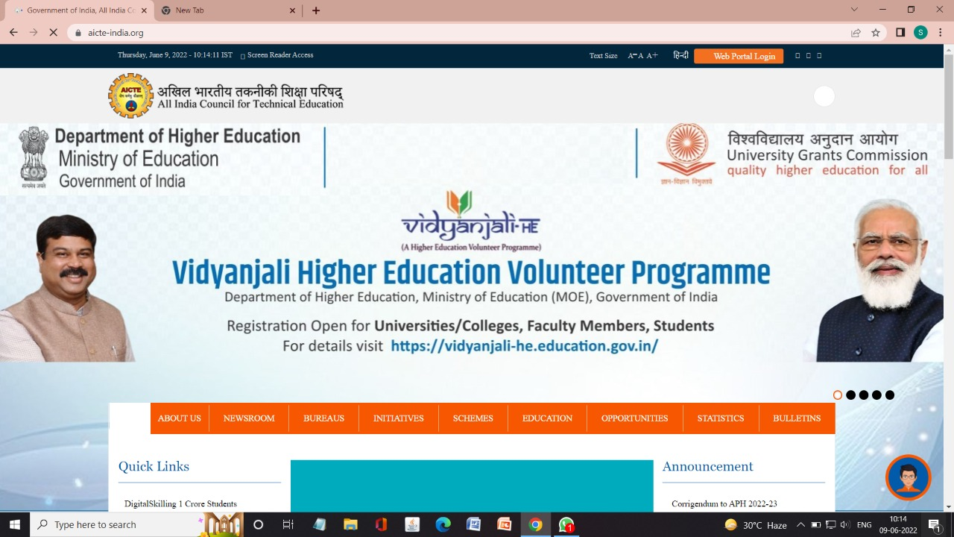

**Fig.4.13.2d**

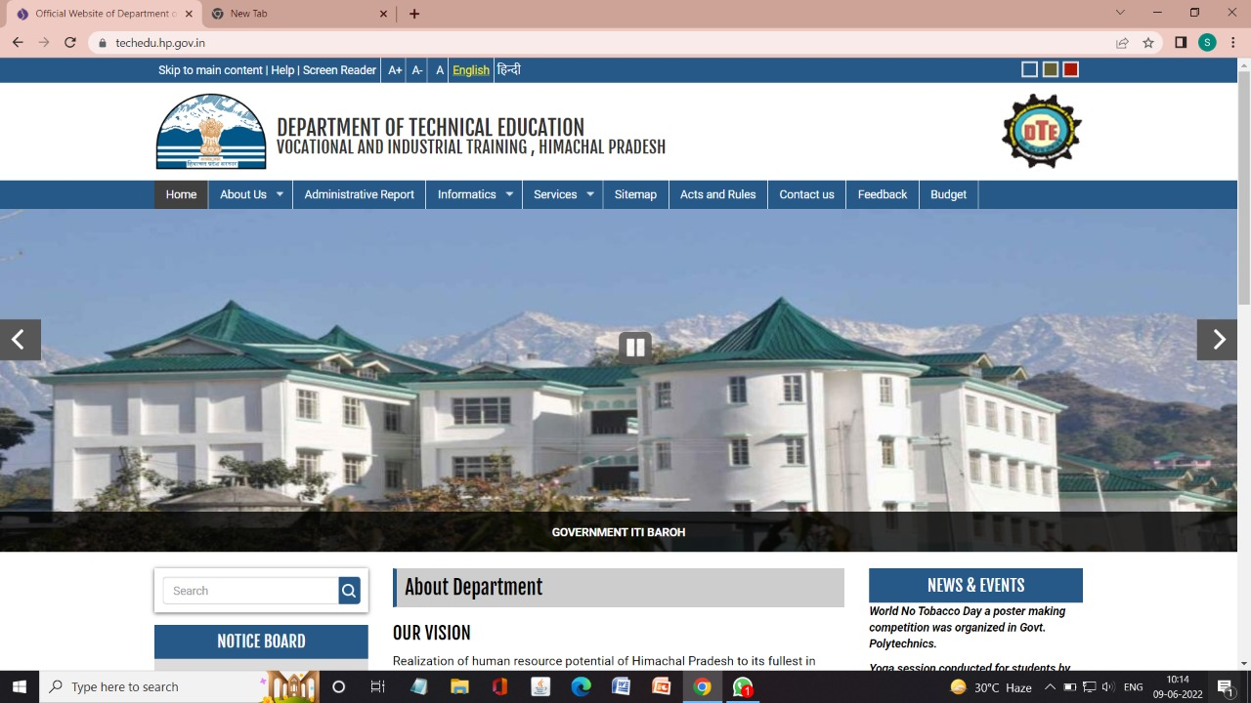

**Fig.4.13.2e**

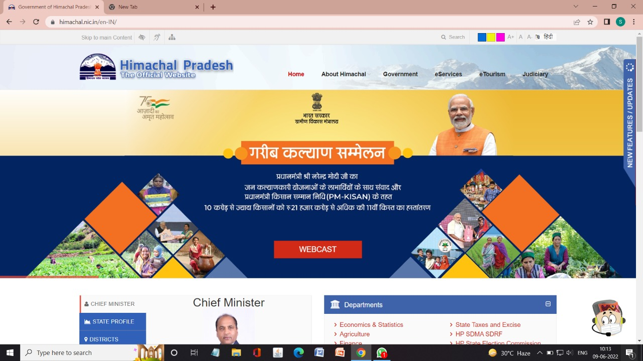

**Fig.4.13.2f**

**CHAPTER – 5**

**WEBSITE TESTING**

**5.1 INTRODUCTION:**

Website testing is a testing process meant to identify errors in a website, web micro-service or any other web-based application. During this phase, website testers evaluate different components of the website and examine each feature, both individually and collectively. The testing procedure is extremely thorough, and QA web testers check the entire web system end-to-end before releasing the website for use. As a result, they are able to evaluate how well the website fulfills its purpose.

**5.2 TESTING TECHNIQUES:**

1. **Documentation Testing:**

We should start with the preparatory phase, testing the documentation. The tester studies the received documentation (analyzes the defined site functionality, examines the final layouts of the site and makes a website test plan for further testing).

The main artifacts related to the website testing are analyzed on this stage:

* Requirements
* Test Plan
* Test Cases
* Traceability Matrix

**2. Website Functionality Testing:**

Functional testing is aimed to ensure that each function of the website operates in conformance with the requirement specification. Website testing of the functionality shows “What the system does”. It includes:

* Link testing
* Cookies testing
* HTML/CSS

**3. Usability Testing:**

Usability testing is aimed to evaluate your web page by testing it with representative users. It helps to define user ability to learn to operate, prepare inputs for, and interpret outputs of your site.

**4. UI (user interface) Testing:**

User Interface (UI) testing is provided to verify the graphic user interface of your website meets the specifications.

Here are some verifications for UI testing of a website:

* Compliance with the standards of graphical interfaces
* Design elements evaluation: layout, colors, fonts, font sizes, labels, text boxes, text formatting, captions, buttons, lists, icons, links
* Testing with different screen resolutions
* Testing of localized versions: accuracy of translation (multi language, multicurrency), checking the length of names of interface elements, etc.
* Testing the graphical user interface on target devices: smartphones and tablets.

**5. Compatibility Testing:**

Compatibility (Configuration) testing is performed to test your website with each one of the supported software and hardware configurations:

OS Configuration

Browser Configuration

Database Configuration

Cross-platform testing: allows evaluating the work of your site in different OS (both desktop and mobile): Windows, iOS/Mac OS, Linux, Android, and BlackBerry etc.

Cross-browser website: testing methods help to verify the correct work of the site in different browser configurations: Mozilla Firefox, Google Chrome, Internet Explorer, and Opera etc.

Database testing is performed to ensure the correct work of your site in different database configurations: Oracle, DB2, MySQL, MSSQL Server, Sybase.

Printing compatibility also should be mentioned in your website test plan:

Verify the fonts, page graphics, page alignment can be printed properly

Ensure all pages of your site fit the paper size and the size defined in the printing option.

**6. Performance Testing:**

Performance testing is aimed to determine how a system performs in terms of responsiveness and stability under a certain load. Sites must withstand high loads.

**7. Security Testing:**

Security testing is performed to verify the information system protects data and maintains functionality as intended.

**Some verifications for the security testing:**

Ensure the unauthorized access to secure pages is not possible

Verify sessions are automatically killed after prolonged user inactivity

Test SSL security functions

All attempts at breaking, reporting errors etc. should be logged and stored in a separate file for further analysis.

Ensure restricted files are not downloadable without appropriate access

Ensure there is no login ability while entering wrong password or username.

**8. Mobile-friendly testing:**

Here are some tips to test your website on mobile:

* Verify the compatibility with smartphones and tablets
* Ensure the site navigation is as simple as possible
* Optimize the loading time of your site
* Ensure buttons are large enough for people with big finger
* Optimize all images size
* Don’t use Flash and pop-ups
* Use bullet points and short sentences
* Ensure your phone number is one click away from being dialed
* Verify the website can access your location through GPS

**9. Beta Testing:**

Beta testing – the final prerelease stage of testing. As a rule, it is done by end-users and out stuff people.

Beta testing replaces your site in the hands of real users outside of your team to discover any weak points from the user’s perspective that you would not want to have in your final, released version of the application.

**CONCLUSION**

The website has been developed for the given condition and is found working effectively. The developed website is flexible and changes can be made easily whenever required. Using the facilities and functionalities of Word press the website has been developed in a neat and simple manner, thereby reducing the operator’s work.

The speed and accuracy are maintained in proper way. The user-friendly nature of website is very easy to work with both the higher administration as well as the user’s with little knowledge of computer .The website is verified and it can be modified as per requirements in the future hence, it can maintained successfully.

**REFRENCES**

YouTube videos

**Website:**

[www.geeksforgeeks.org](http://www.geeksforgeeks.org)

Chandigarh University

IIT Madras

**Dashboard**

The WordPress Dashboard is a first screen which will be seen when you log into the administration area of your blog which will display the overview of the website. It is a collection of gadgets that provide information and provide an overview of what's happening with your blog.

**Colibri**

Colibri Cloud is your online workspace for WordPress sites. You can create websites in your Colibri account, share them with your colleagues or clients and publish to any hosting when you're ready.

**Customizer**

The Customizer is where you will go to take your site's Theme to the next level. From this section, you can change your Site Title and Tagline, add Widgets to a Sidebar or Footer, create Menus, change your Homepage Settings, and more. Some options found in the Customizer will be different based on different themes.

**Theme**

A WordPress theme is a group of files (graphics, style sheets, and code) that dictates the overall appearance of your blog or website. Themes can control something as vast as your site's layout, or as minute as your hyperlink colors.

**Widget**

A WordPress widget is a modular element that enables you to add a specific feature to your website. Widgets can be added to different areas of a website, such as a website's sidebars or footer areas, and they're an inherent part of WordPress' design and layout customizations.

**Plugin**

A WordPress plugin is a package of additional code that you can upload to your website to add new features, functionality or integrations.

* Plugins can be added via the Plugins menu in your WordPress dashboard.
* Using the built-in search function, you can find a free plugin available on the WordPress.org Plugin directory.
* Plugins can also be packaged as zip files that you upload through the Plugins menu uploader in your WordPress dashboard.

**Sitemap**

A sitemap (or site map) is a file that provides information about the pages, posts, and other files on your site, and the relationships between them. Search engines like Google read this file to more intelligently crawl your site.

**Reusable Block**

Blocks » Reusable Block. With reusable blocks, you can save a block (or a group of blocks) to use later in any post or page on your site. If you're repeatedly adding the same content to the same block or group of blocks, the reusable blocks will save you a lot of time.

**Template**

A template provides the structure for how your content is displayed. It's a file generated by your WordPress theme that can be applied to specific posts or pages to control the way they look on your website. Templates vary from theme to theme.

**Traceability Matrix**

A traceability matrix is a document, sometimes in the form of a table ,that will provide a cross reference between all the documentation and software code in a system.

**User Interface (UI)**

In WordPress, the UI is also the backend admin user panel and tools that enable all content and web production. It is important for WordPress developers to build a functional dashboard with a highly operative and proficient UI.

**Secure Sockets Layer (SSL)**

It is the standard for encrypted communication between servers and browsers. A browser receives and interprets this certificate and verifies its authenticity. Once the verification has been performed, all the data sent through the secure connection is encrypted.